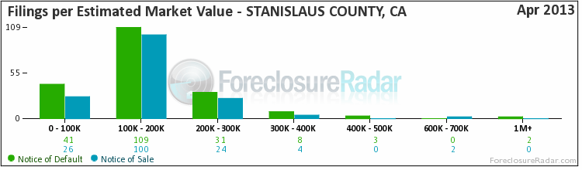
Filings By Est. Market Value—The number of foreclosures that have received either a Notice of Default or Notice of Sale, shown in columns arranged by the estimated market value of the property in foreclosure.
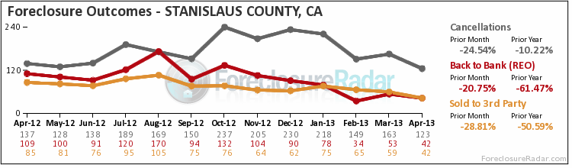

Foreclosure Outcomes—After the filing of a Notice of Trustee Sale, there are only three possible outcomes. First, the sale can be Cancelled for reasons that include a successful loan modification or short sale, a filing error, or a legal requirement to re-file the notice after extended postponements. Alternatively, if the property is taken to sale, the bank will place the opening bid. If a 3rd party, typically an investor, bids more than the bank’s opening bid, the property will be Sold to 3rd Party; if not, it will go Back to the Bank and become part of that bank’s REO inventory.

I need to explain these two graphs and formulate the range value of foreclosures year to date for the Stanislaus County.

