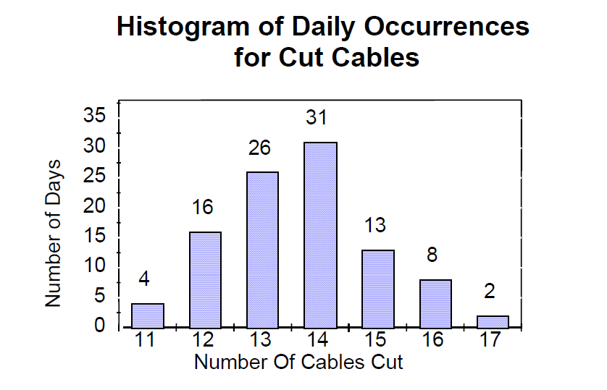

Develop the discrete process generator needed to generate number of cables cut per day using this table:

