Mortgages Unlimited

Consider a local mortgage processing firm. They follow the process flow below. They work 8 hours per day. (Note that there are no buffers and no variability.)

Accept Mortgages
Credit Report
45 min
Title Search
30 min
Final Approval
15 min
Property Survey
90 min

- Find the average daily capacity of the workstations listed below. Assume one employee per workstation. Show your work.

Capacity of Credit Report __________________ mortgages per day

Capacity of Title Search __________________ mortgages per day

Capacity of Property Survey __________________ mortgages per day

Capacity of Final Approval __________________ mortgages per day

- (12 points) Fill in the following table, showing work where appropriate. Don’t forget to put units.
Question | Answer | Work (if needed)
Where is the bottleneck?

What is the system capacity in mortgages/day?
What is the flow (throughput) time of a mortgage (ignoring any queuing)?
What is the cycle time of the process?
What is the throughput rate of the entire process?
Assuming demand is very high so it does not limit the system, what is the utilization of the title search step?
Assuming one employee does the entire process, what is the cycle time?
Assuming one employee does the entire process, what is the flow (throughput) time?

- An MBA student has redesigned the process, so now the property survey can be done in parallel with the credit report and title search step as shown in the process flow below.
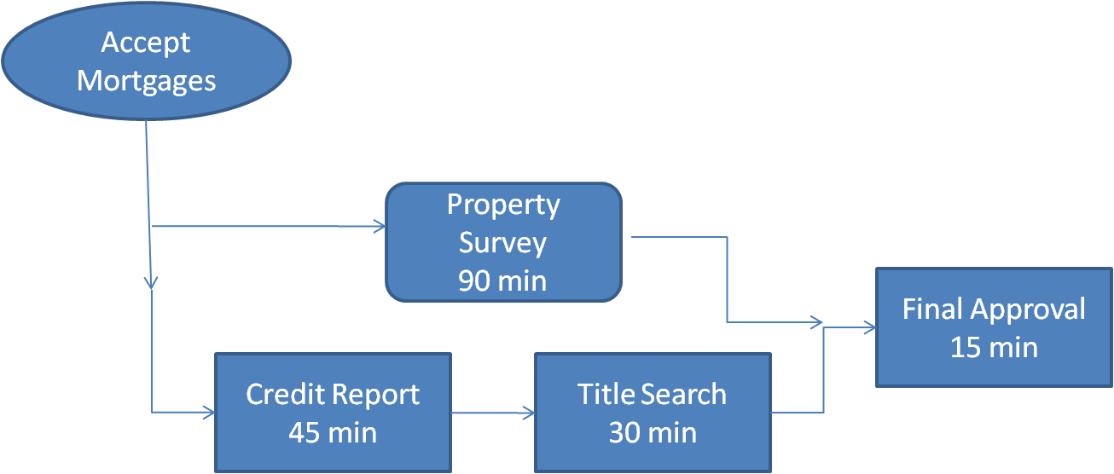

(8 points) How many employees do you need for this process and why? Be specific.

