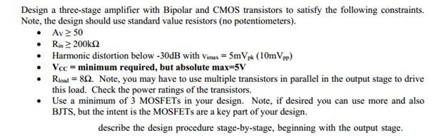
Needed PSPICE simulation results:
