http://www.quora.com/When-I-fill-up-my-water-bottle-why-do-the-sounds-become-lighter-as-the-bottle-fills-up
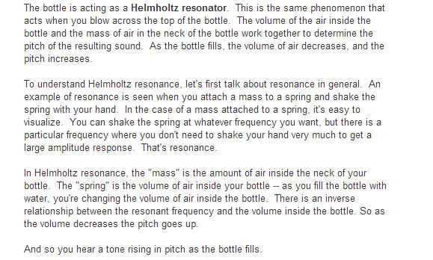
Question 1: I initially thought the resonance in a water bottle where the sound from blowing in it is produced so that when you blow into a bottle the air molecules will get a certain speed constrained by friction and initial velocity and kinetic energy needed to accelerate them and if you blow so that it hits the water at end or middle of the wave the frequency of the wave going back will not interfere with the incident wave as shown here
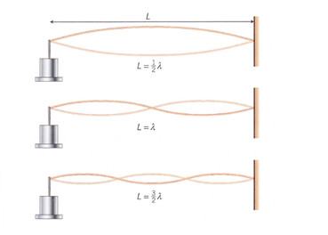
But longitudinal waves does not travel with sinus waves they only travel in direction it is propagating? How is resonance then determinded for longitudinal waves?
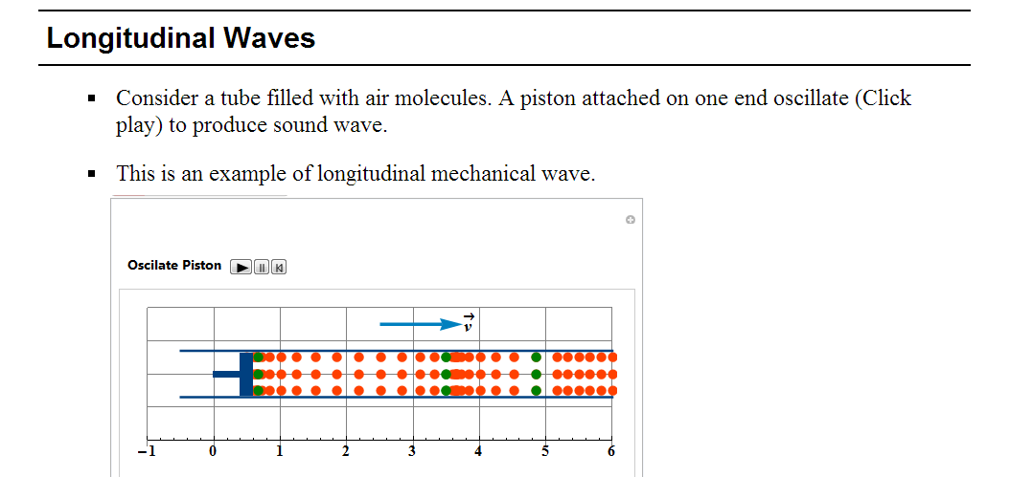
The two last question is from this site
http://hyperphysics.phy-astr.gsu.edu/hbase/waves/powstr.html#c2
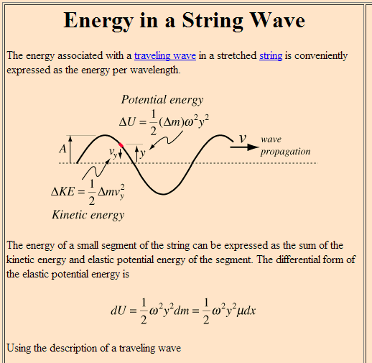
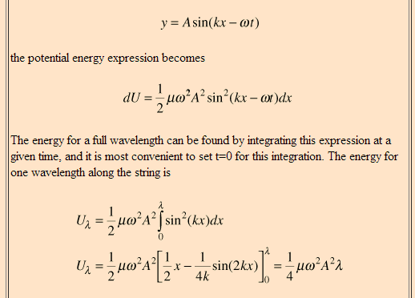
Question 3: Why do they get sum of potential energy from this integration when one wavelength end and starts at same height? Would not sum of potential energy change then be 0?
Question 4: where do they get this velocity expression from?
The rest is no problem:
