Then the 27 listed insurance agents Nationwide Insurance in the metropolitan area of ​​Toledo, Ohio. you want to calculate the average number of years that have worked in Nationwide.

Number of Agent number of Agent Number of Agent
Identification Identification Identification
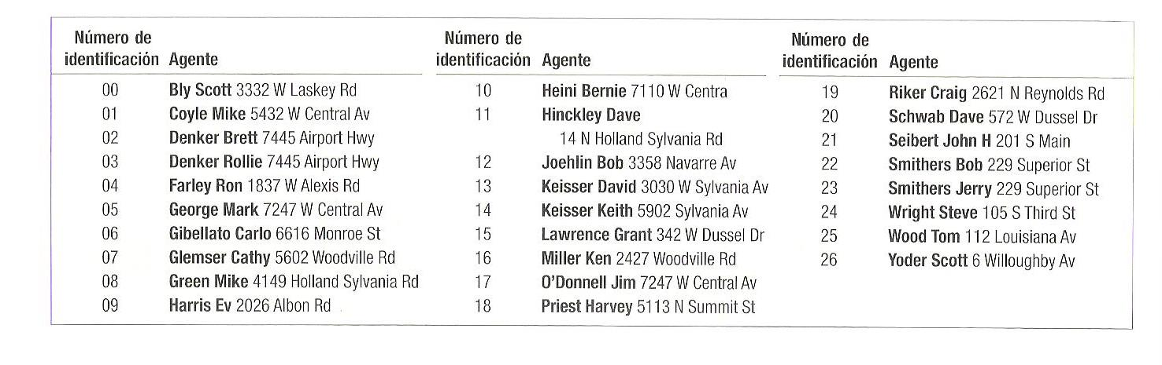

methods of sampling and central limit theorem
a) select a random sample of four agents. Random numbers are
02,59,51,25,14,29,77,69 and 18 dealers will be included in the sample?
b) Use the table of random numbers to select their own sample of four agents.
c) A sample consists of every seventh dealer. The number 04 is selected as a starting point. That members be included in the sample?

