Comprehensive Process Costing: Weighted-Average Method

AJ's Bakery bakes apple fritters for sale to area grocery stores. The company uses the weighted-average method of process costing to account for the cost of the apple fritters it produces. Raw materials (flour, sugar, flavoring, apples) and conversion costs are incurred at the same rate during the production process. Data for AJ's Bakery are as follows:

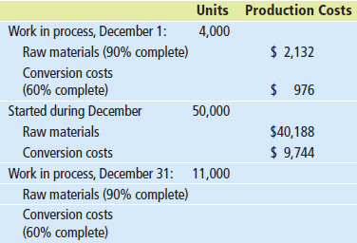

Required:
A. How many units were completed in December?
units
B. How many equivalent units were completed in December for raw materials and conversion costs?
Raw Materials | equivalent units
Conversion Costs | equivalent units
C. What is the cost per equivalent unit for raw materials and conversion costs? Round your answer to six decimal places if necessary. Use your rounded answer for subsequent calculations.
Raw Materials | $ per equivalent unit
Conversion Costs | $ per equivalent unit
D. What is the cost of ending WIP?
$
E. What is the cost of the units transferred out of work in process inventory to finished-goods inventory? That is, what is the cost of goods manufactured during December?
$Item 7

A) Add beginning WIP inventory and units started. Subtract ending WIP inventory for units completed.
B) For DM, add together the number of units completed and the number of EU with DM costs in ending WIP. For Conversion Costs, add together the number of units completed and the number of EU with Conversion Costs in ending WIP.
C) For both DM and CC, add beginning WIP costs and current period costs for total costs. Divide total costs by EU for both DM and CC for cost per EU.
D) For both DM and CC, multiply the number of equivalent units in ending inventory by the percentage complete. Multiply each by their respective cost per EU to get the cost of ending WIP for DM and CC.
E) Add beginning WIP for both DM and CC to current period costs for both DM and CC. Subtract out the cost of ending WIP (part "D") to get CGM.

