Density
- Calculate the density of chloroform using the data in the picture below.
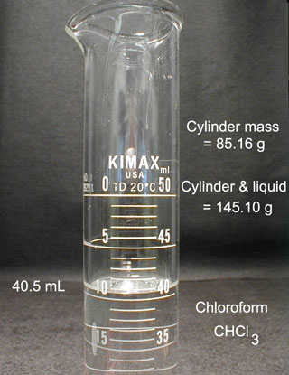
- A glass sample bottle weighs 24.225 g when empty. When filled with carbon tetrachloride, CCl₄, it weighs 28.715. If the density of carbon tetrachloride is 1.5842 g/mL, what is the volume of the sample bottle in milliliters?
- An empty vial weighs 61.29 g.
- If the vial weighs 180.77 g when filled with liquid mercury (d = 13.53 g/cm³), what is its volume?
(b) How much would the vial weigh if it were filled with water (d = 0.997 g/cm³ at 25°C)?
When determining sigfigs, assume the same balance is being used for both parts.
- What is the density (g/ml) of a 100 ml sample of water that has 25 grams of NaCl added to it. (assume no volume change). Round your answer to two decimal places, do not include units in your answer.
- A block of metal weighs 27.0 g and has a volume of 10.0ml. Calculate the density, and then using the table in the lab, what is the metal most likely to be? Spelling counts. If there are multiple spellings, we will be using the spelling and naming conventions found in your text. Do not include the density in your answer, only the name of the metal.

