Please help me with the following questions. I am going to have some similar questions in my test and I would like to get ready, and use this as a study guide. Please use Excel showing step by step so I can understand.

1. Coach Bjourn Toulouse led the Big Red Herrings to several disappointing football seasons. Only better recruiting will return the Big Red Herrings to winning form. Because of the current state of the program, Boehring University fans are unlikely to support increases in the $ 192 season ticket price. Improved recruitment will increase overhead costs to $ 30,000 per class section from the current $ 25,000 per class section. The university’s budget plan is to cover recruitment costs by increasing the average class size to 75 students. Labor costs will increase to $ 6,500 per 3- credit course. Material costs will be about $ 25 per student for each 3- credit course. Tuition will be $ 200 per semester credit, which is supplemented by state support of $ 100 per semester credit.
a.What is the multifactor productivity ratio? 1, did productivity increase or decrease for the course process?
b.If instructors work an average of 20 hours per week for 16 weeks for each 3- credit class of 75 students, what is the labor productivity ratio?

2.Suds and Duds Laundry washed and pressed the following numbers of dress shirts per week.
Week Work Crew Total Hours Shirts
1 Sud and Dud 24 68
2 Sud and Jud 46 130
3 Sud, Dud, and Jud 62 152
4 Sud, Dud, and Jud 51 125
5 Dud and Jud 45 131
a.Calculate the labor productivity ratio for each week.
b.Explain the labor productivity pattern exhibited by the data.

3.CD players are produced on an automated assembly line process. The standard cost of CD players is $ 150 per unit (labor, $ 30; materials, $ 70; and overhead, $ 50). The sales price is $ 300 per unit.
a.To achieve a 10 percent multifactor productivity improvement by reducing materials costs only, by what percentage must these costs be reduced?
b.To achieve a 10 percent multifactor productivity improvement by reducing labor costs only, by what percentage must these costs be reduced?
c.To achieve a 10 percent multifactor productivity improvement by reducing overhead costs only, by what percentage must these costs be reduced?

4.The output of a process is valued at $ 100 per unit. The cost of labor is $ 50 per hour including benefits. The accounting department provided the following information about the process for the past four weeks:
Week 1 Week 2 Week 3 Week 4
Units Produced 1,124 1,310 1,092 981
Labor ($) 12,735 14,842 10,603 9,526
Material ($) 21,041 24,523 20,442 18,364
Overhead ($) 8,992 10,480 8,736 7,848
a.Use the multifactor productivity ratio to see whether recent process improvements had any effect and, if so, when the effect was noticeable.
b.Has labor productivity changed? Use the labor productivity ratio to support your answer.

5.Alyssa’s Custom Cakes currently sells 5 birthday, 2 wed-ding, and 3 specialty cakes each month for $ 50, $ 150, and $ 100 each, respectively. The cost of labor is $ 50 per hour including benefits. It takes 90 minutes to produce a birth-day cake, 240 minutes to produce a wedding cake, and 60 minutes to produce a specialty cake. Alyssa’s current multifactor productivity ratio is 1.25.
a.Use the multifactor productivity ratio provided to calculate the average cost of the cakes produced.
b.Calculate Alyssa’s labor productivity ratio in dollars per hour for each type of cake.
c.Based solely on the labor productivity ratio, which cake should Alyssa try to sell the most?
d.Based on your answer in part (a), is there a type of cake Alyssa should stop selling?

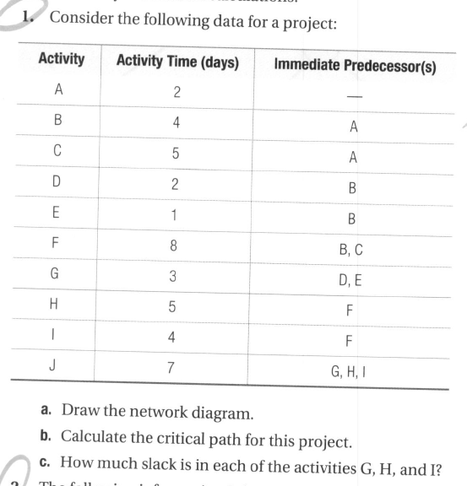
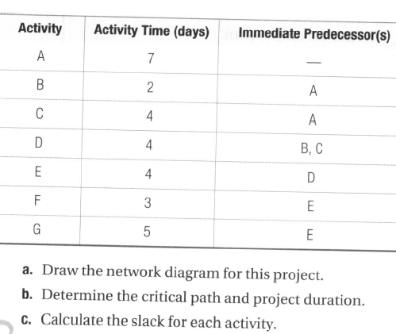

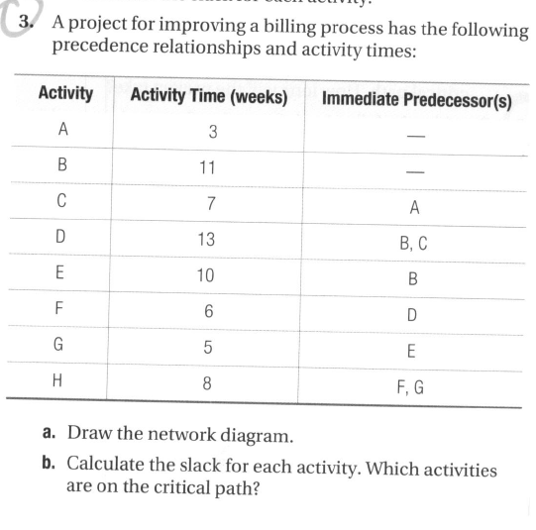

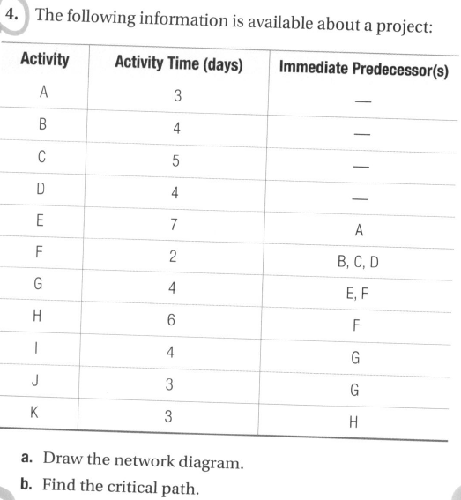
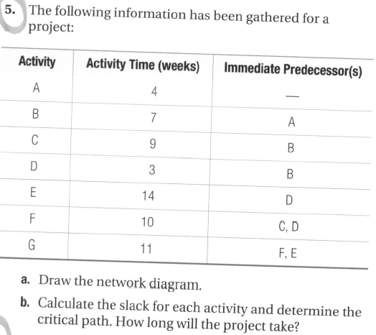
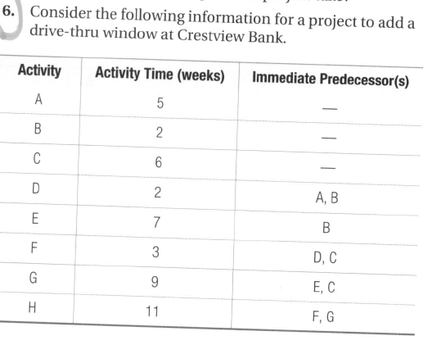
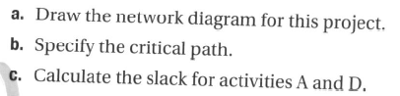

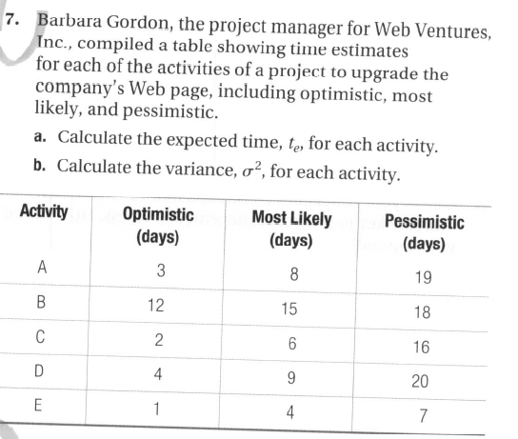

Please use any company
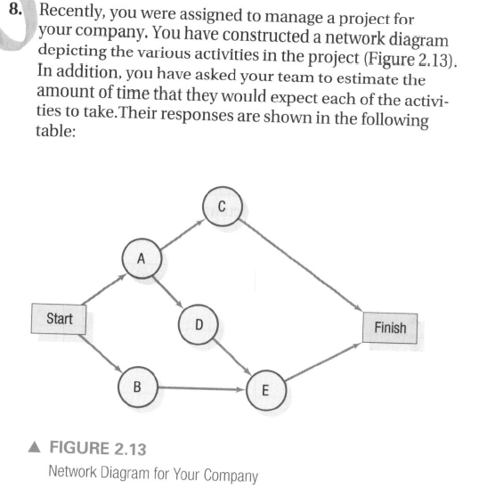
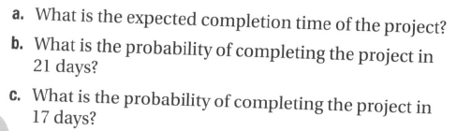
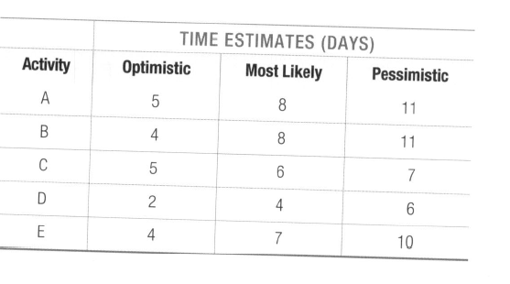
Question 9
