- Identify and test the research hypothesis at the .05 level of significance that boys raise their hands in class more often than girls. Remember to first decide whether this is a one- or two-tailed test. What is your conclusion regarding the research hypothesis?

Group Statistics
 | Gender | N | Mean | Std. Deviation | Std. Error Mean
hands up | Boys | 14 | 7.93 | 2.369 | .633
 | Girls | 16 | 5.31 | 2.387 | .597

Independent Samples Test
 |  | Levene's Test for Equality of Variances |  | t-test for Equality of Means
 |  | F | Sig. | t | df | Sig. (2-tailed) | Mean Difference | Std. Error Difference | 95% Confidence Interval of the Difference
 |  |  |  |  |  |  |  |  | Lower | Upper
hands up | Equal variances assumed | .477 | .495 | 3.006 | 28 | .006 | 2.616 | .870 | .833 | 4.399
 | Equal variances not assumed |  |  | 3.007 | 27.529 | .006 | 2.616 | .870 | .833 | 4.399

- Test the research hypothesis at the .01 level of significance that there is a difference between boys and girls in the number of times they raise their hands in class. What is your conclusion regarding the research hypothesis?

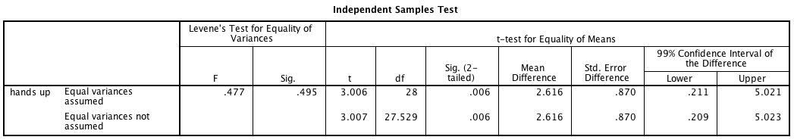

- You used the same data for both parts a and b, but you have a different hypothesis (one is directional and the other is non-directional). How do the results differ and why?

