3. The following table lists the components needed to assemble an end item, lead times (in weeks), and quantities on hand.
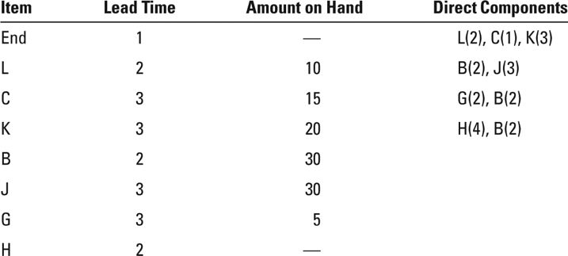
a. If 40 units of the end item are to be assembled, how many additional units of B are needed? (Hint: You don’t need to develop an MRP plan.)
b. An order for the end item is scheduled to be shipped at the start of week 8. What is the latest week that the order can be started and still be ready to ship on time? (Hint: You don’t need to develop an MRP plan.)

