The ruler below measures in arcmins. Using what you have learned about precise measurement, how long is the line in arcmins?
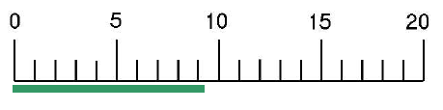
Examine the graduated cylinder below. Choose the best volume reading. You have only ONE submission for this question.
