We can draw an analogy between the attraction of an electron to a nucleus and seeing a lightbulb-in essence, the more nuclear charge the electron "sees," the greater the attraction.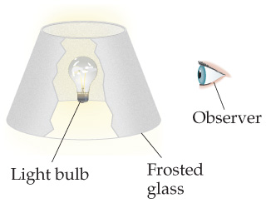

- Within this analogy, discuss how the shielding by core electrons is analogous to putting a frosted-glass lampshade between the lightbulb and your eyes, as shown in the illustration. (See figure above)
- Explain how we could mimic moving to the right in a row of the periodic table by changing the wattage of the lightbulb. (See figure above)
- How would you change the wattage of the bulb and/or the frosted glass to mimic the effect of moving down a column of the periodic table? (See figure above)
- What is meant by the term effective nuclear charge?
- Explain the following variations in atomic or ionic radii.
  - I⁻ >I>I⁺
  - Ca²⁺ >Mg²⁺>Be²⁺
  - Fe >Fe²⁺>Be³⁺
- For each of the following pairs, indicate which element has the larger first ionization energy.
  - Ti, Ba (Use electron configuration and effective nuclear charge to explain your answer)
  - Ag, Cu (Use electron configuration and effective nuclear charge to explain your answer)
  - Ge, Cl (Use electron configuration and effective nuclear charge to explain your answer)
  - Pb, Sb (Use electron configuration and effective nuclear charge to explain your answer)
- Explain how the 4s electron in an As atom has a lower energy that 4p electron in an As atom? Also, how can we use the concept of effective nuclear charge to explain this?
- How do we determine the factors of the order of increasing melting point?

- For each of these Lewis symbols,(Figure below) indicate the group in the periodic table in which the element X belongs:

Enter your answers in order given in the figure below. For example, Chlorine is in group 7A.
