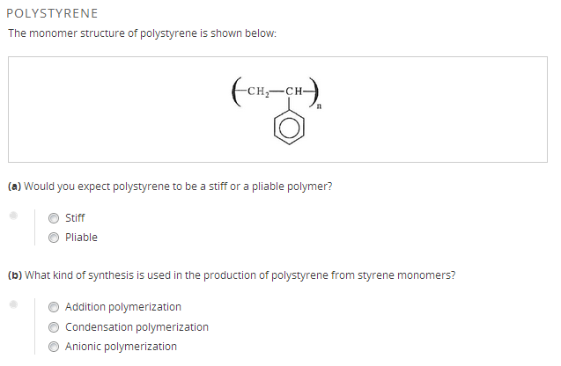
2.)
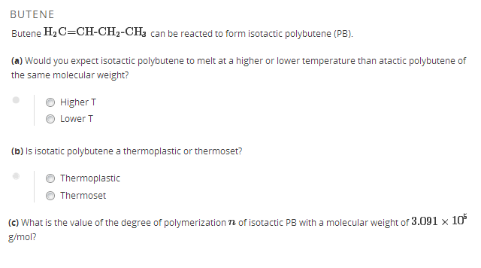
3.)

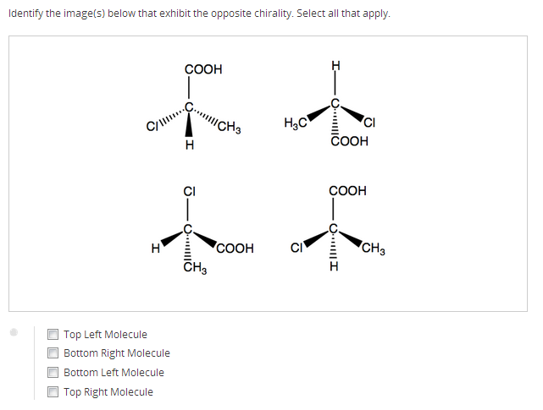
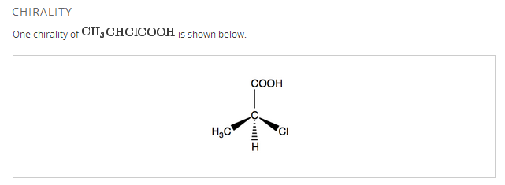

4.)

GLASS TRANSITION AND MECHANICAL PROPERTIES
Describe how the mechanical properties of a purely amorphous cross-linked polymer above its glass transition temperature differ from the mechanical properties of a purely amorphous cross-linked polymer below its glass transition temperature. Consider properties such as Young's modulus and as well as whether you would expect the polymer to undergo plastic flow or brittle fracture.

