- A jet flying at 236.9 km/hr travels between two cities in 1.3 hour(s). A turboprop flying the same route takes 5.2 hours. What is the speed of the turboprop?

- A 9.0 kg block is free to slide on a frictionless horizontal surface. A force of 4.6 N is applied to the block at an angle of parallel to the horizontal. Find the acceleration of the block (acceleration horizontal only).

- A ball thrown straight up with a velocity of 3.0 m/s. How long (seconds) will it take for the ball to reach the highest point?

- Initially a woman exerts a constant horizontal force on a large box. As a result, the box moves across a horizontal floor at constant speed "v0". The woman then doubles the constant horizontal force that she exerts on the box to push it on the same horizontal floor. The box then moves:

- Two students push a small car down the driveway. The momentum of the 504.7 kg car is plotted as a function of time in the graph above and reaches 3000 kg m/s in 4 seconds. What is the average force of push by each student during the push?
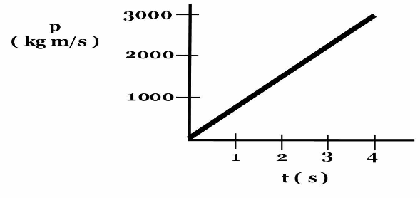
- The figure depicts a hockey puck sliding with constant speed v₀ in a straight line from point "a" to point "b" on a frictionless horizontal surface. Forces exerted by the air are negligible. You are looking down on the puck. When the puck reaches point "b," it receives a swift horizontal kick in the direction of the heavy print arrow. Had the puck been at rest at point "b,", then the kick would have sent the puck in horizontal motion with a speed v_{k} in the direction of the kick.

Along the frictionless path taken by the puck after receiving the kick:
a. is constant for a while and decreases thereafter.
b. continuously decreases.
c. continuously increases.
d. increases for a while and decreases thereafter.
e. is constant.
- A 1353.12 kg car traveling north at 19.84 m/s collides with a 2092.43 kg pickup truck traveling east at 27.04 m/s. The car and pickup truck are locked together at the instant of the collision. What speed do these vehicles go immediately after the collision?

- What is the tension on a cable attached to the top of an elevator (with a mass of 1289.2 kg) that is slowing down at 4.54 m/s2as is travels in the downward direction?

- A car accelerates at a constant rate of 5.37 m/s2 from rest at the beginning of a freeway entrance ramp. At the end of the ramp the car has a speed of 26.91 m/s. How long is the ramp?

- A lab team acquires data and establishes a mathematical expression that relates circumference to the diameter of circular objects.
The mathematical model is:
Circumference = 7.2 (Diameter) + 12.6 cm
Using the results of this research what would the team estimate the circumference for a circular object with a diameter of 705.7 cm?

