- A plane leaves the airport and flies east at 109 miles/hour. 4.5 hour(s) later a second plane leaves east at 240 miles/hour. How long after taking off does the second plane overtake the first plane?

- What is the tension on an elevator cable if the elevator (with a mass of 1209.3 kg) is traveling up at 4.2 m/s?

- A ball thrown straight up with a velocity of 4.8 m/s. How long will it take to return to the thrower?

- A ball is fired by a cannon from the top of a cliff as shown in the figure. Which of the paths would the cannon ball most closely follow?
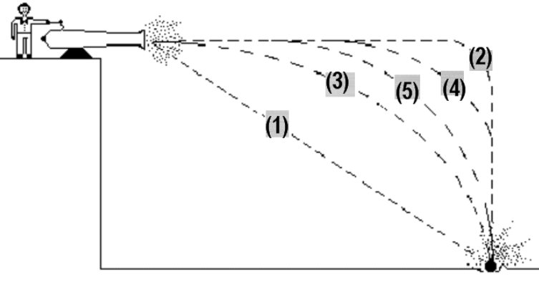
a. 1
b. 5
c. 3
d. 4
e. There is no best selection to answer this question.
f. 2

- The graph below depicts the force of a hydraulic hammer pushing on a roller coaster on a straight and level track with no friction. What is the change in momentum of the roller coaster on during the first 6.5 seconds?
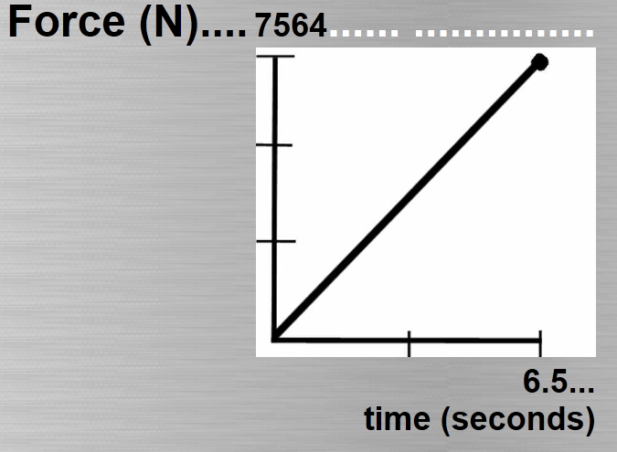

- A large truck collides head-on with a small compact car. During the collision:
a. the truck exerts a force on the car but the car does not exert a force on the truck.
b. the car exerts a greater amount of force on the truck than the truck exerts on the car.
c. neither exerts a force on the other, the car gets smashed simply because it gets in the way of the truck.
d. the truck exerts a greater amount of force on the car than the car exerts on the truck.
e. the truck exerts the same amount of force on the car as the car exerts on the truck.

- Five students push a small car down the driveway. The momentum of the 1191.1 kg car is plotted as a function of time in the graph above and reaches 3000 kg m/s in 4 seconds. What is the average force of push by each student during the push?

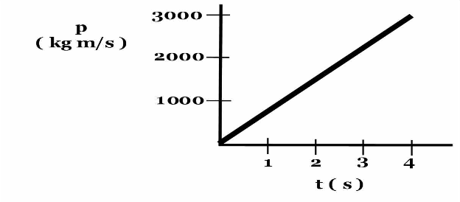
- A locomotive of mass 3532.8 is rigidly attached to a railroad car of mass 2487.3 riding without friction on a horizontal track. If the locomotive, which has a coefficient of static friction 0.6, exerts a force of 3933.1 N on the railroad car, what is the magnitude of the acceleration of the locomotive?

- A bicycle accelerates from rest at 3.5 m/s2 for 1.6 seconds. What is the total distance traveled?

- A jet flying at 206.0 km/hr travels between two cities in 1.5 hour(s). A turboprop flying the same route takes 5.5 hours. What is the speed of the turboprop?

