FIGURE 9-2 Relationship between data modeling and the systems development life cycle.

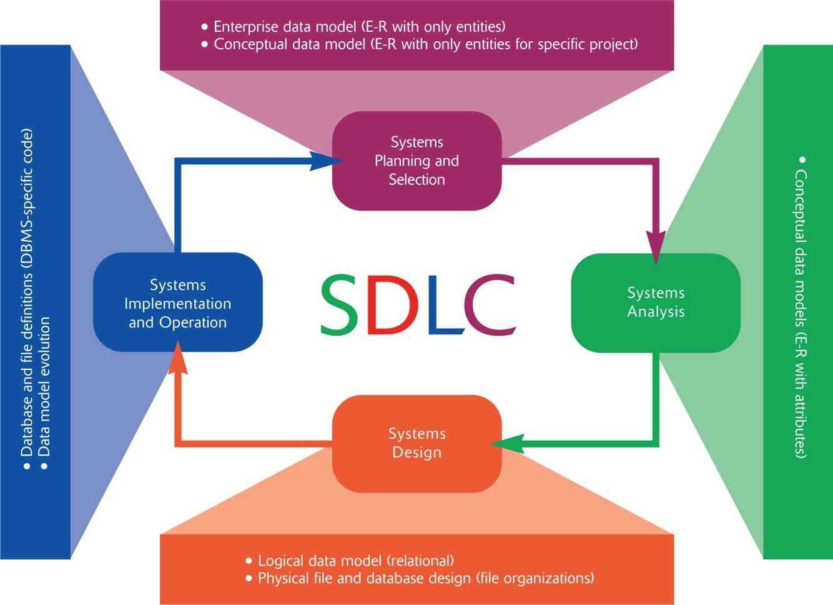
- 1. Choosing the storage format (called data type) for each attribute from the logical database model; the format is chosen to minimize storage space and to maximize data quality. Data type involves choosing length, coding scheme, number of decimal places, minimum and maximum values, and potentially many other parameters for each attribute.
- 2. Grouping attributes from the logical database model into physical records (in general, this is called selecting a stored record, or data structure).
- 3. Arranging related records in secondary memory (hard disks and magnetic tapes) so that individual and groups of records can be stored, retrieved, and updated rapidly (called file organizations). You should also consider protecting data and recovering data after errors are found.
- 4. Selecting media and structures for storing data to make access more efficient. The choice of media affects the utility of different file organizations. The primary structure used today to make access to data more rapid is key indexes, on unique and non-unique keys.

