Project Statement:

The machine shown in the figure is rigidly anchored on a rigid concrete block and the mass of both is 3000 kg. The block has height h = 1 m and square horizontal section with a = 1.2 m and is supported at the corners by 12 springs of stiffness k = 2000 N/m.

- Derive the equations of motion of the system using both Newton’s law of motion and Lagrange’s equations methods.

- Find the natural frequencies and mode shapes of the system using both hand calculations and Matlab.

- A 200-kg mass falls on the middle of one edge of the block and stayed in contact with it. Neglecting the change in the mass, determine the resulting motion.

- If the block is isolated by layers of elastic materials in a rigid concrete base. Design the isolation if the machine has parts that rotate at 250, 500, and 1500 rpm.

- If there is unbalanced mass of 0.1 kg on the machine at a distance of 0.25 m from the axis of rotation and angular velocity of 1750 rpm. Find the resulting vibration.

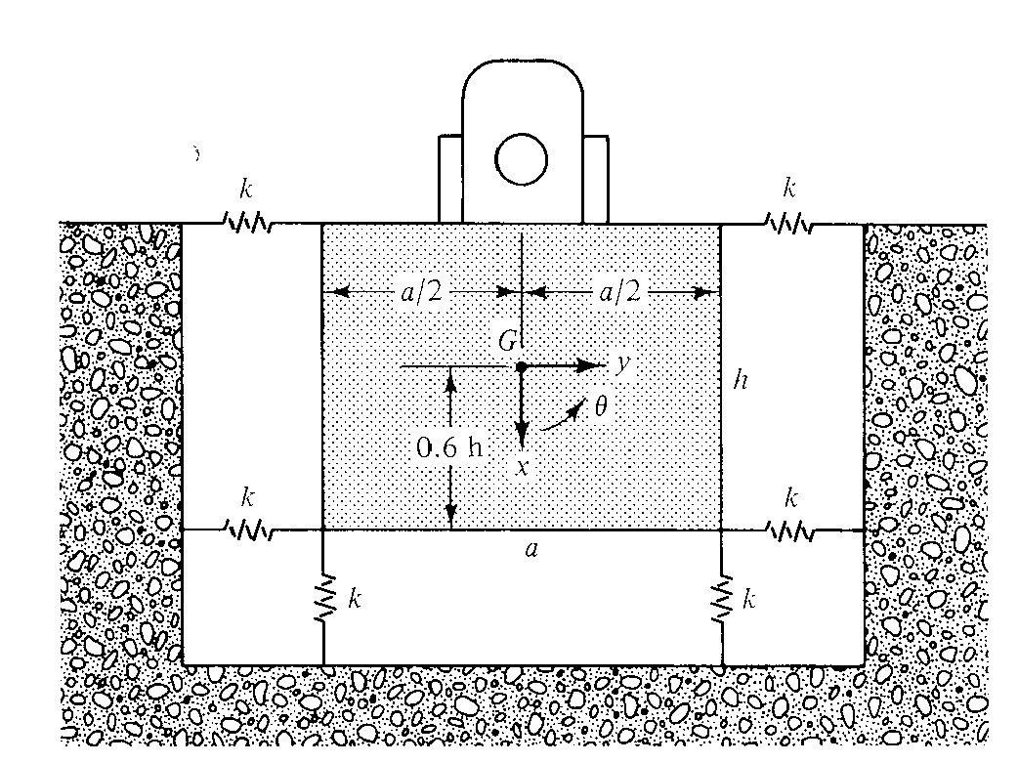

Hint:
The problem has 3 degrees of freedom x, y, and theta.
The moment of inertia for the system can be calculated by using standard formula, however, you can use a value of 640 kgm^2 for the block moment of inertia.

