- (a) DEFECTS
Metals yield at a stress much lower than those calculated on the basis of their bond strength alone. This is explained by the presence of defects. Identify the principal defects responsible for this observation.

- Grain Boundaries
- Interstitial Metal Atoms
- Vacancies
- Dislocations

1.) (b) DEFECTS IN GOLD
You have a single crystal of 100% pure gold. Identify which of the following defects you would expect to be present at room temperature.
- Free surface
- Grain Boundaries
- Vacancies
- Inclusions
- Substitutional impurity atoms
- Interstitial impurity atoms.

RATE OF REACTION
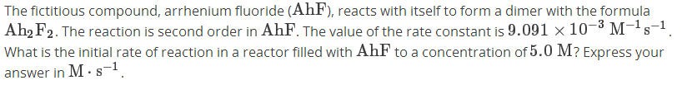

RATE OF REACTION
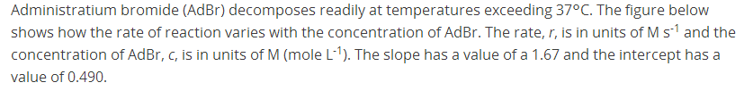
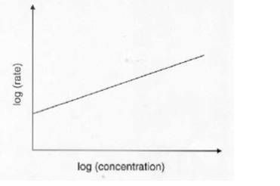

HALF-LIFE
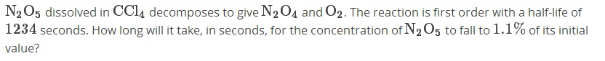

URBIUM OXIDE
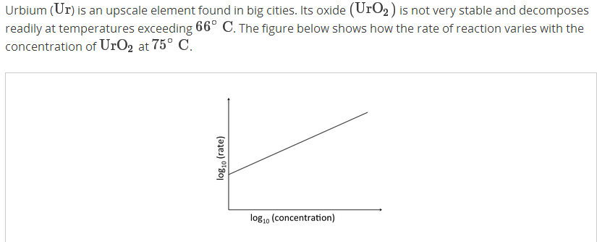

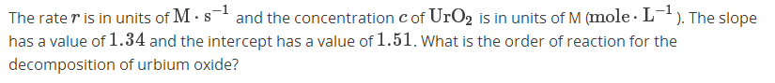
(b)
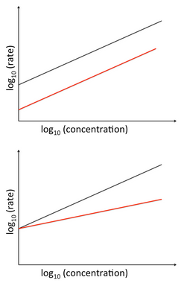
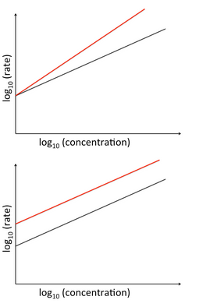

YOUNG'S MODULUS

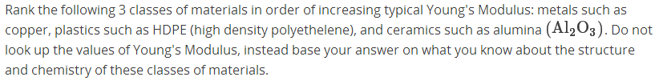

Metals

Plastics

Ceramics

ELONGATION

A steel cable 10 m long is pulled in tension with a stress of 350 MPa. Assume that the Young's modulus of the steel cable is about 200 GPa. If only elastic deformation occurs, what is the resultant elongation in cm?

