STEP 1
Review the ERD below to understand the entities, attributes, primary keys, and relationships that you will create in your Access database.
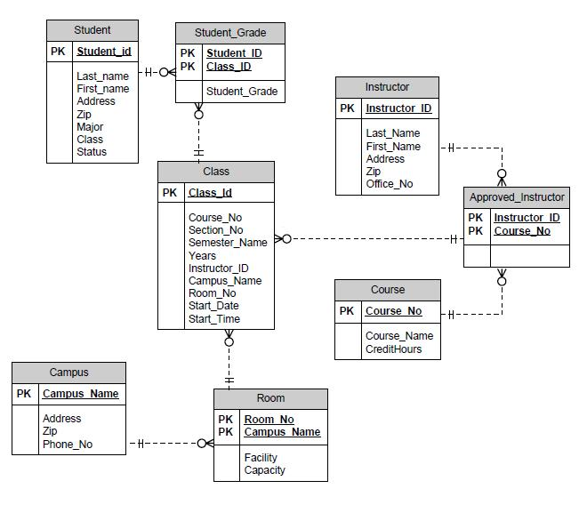

STEP 2

• Run Access 2010.
• Select the blank database icon in the main window.

STEP 3
Add tables to the Access database.
• Add a table for each entity listed in the provided ERD diagram.
• Add a column for each attribute listed in the provided ERD diagram.
• Select a primary key for each table as indicated in the provided ERD diagram.

STEP 4
For every column in every table, update the data type as needed to enforce the domain constraints of the data.
• Dates should have a date data type.
• Surrogate keys should be autonumbered.
• Numeric data should have a numeric data type.
• Character data should have a character data type.

STEP 5
Draw relationships between your entities.
- Selection Relationships under Database Tools. Move all your tables into the Relationship window by dragging them in or by using the Show Tables pop-up window.
- Second item
  - Add the relationship between the tables in your database.
  - Enable referential integrity on the relationship.
  - Enable cascade updates on the relationship.
STEP 6
Add at least two rows of data to each table in your database. Use any values you like for each of the columns. Remember that you must add data to parent tables before adding data to child tables, because referential integrity is enabled.
STEP 7
Set the following column constraints in your database.

• Student first and last name cannot be a null value.
• Course credit hours must be between one and four.
• Course name must be unique and cannot be a null value.
• Instructor first and last name cannot be a null value.
• Grade must be one of these values: A, B, C, D, F, I, W, or E. W signifies withdrawn and E signifies enrolled.

