Problem B
A university needs to put together a committee to handle students’ complaints. To ensure that all perspectives are represented, it is necessary to have a diverse committee by including at least one female, one male, one student, one administrator and one faculty member. Ten individuals have been nominated but since it is important to maintain the anonymity of the committee, the individuals are identified by the letters A to J. The mix of individuals in the different categories is given as follows:
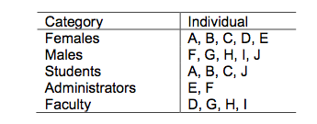
The university wants to form the smallest committee possible with representation from each of the five categories.

a) Formulate a linear mathematical model to find the optimal solution and put it in standard format. Clearly define your decisions variables, objective function and constraints

b) Implement your model in Excel and use Solver to find the optimal solution. Include a snapshot of your answer in the report

c) If individuals (A) and (F) do not get along, and therefore, we cannot have them together on the committee, what would be the new linear constraint that can model this condition? Just include the constraint without repeating the whole formulation and remember that the model must remain linear (i.e., no IF-THEN or similar functions are allowed). Implement this additional condition in Excel and provide the new solution.

d) Suppose that in addition to the condition in part (c), faculty member (I) may have to decline joining the committee due to a project commitment, in which case student (A) must also decline to be on the project with her professor. What would be the new linear constraint that can model this condition? Just include the constraint without repeating the whole formulation and remember that the model must remain linear (i.e., no IF-THEN or similar functions are allowed). Implement this additional condition in Excel and provide the new solution.

