Problem A
A company has three workers. On a particular day, six jobs are scheduled to be completed. The cost for each worker to do each job is shown below.

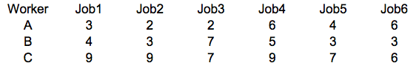

For each of the following questions, formulate a linear mathematical model in a standard format and implement it in Excel to find the optimal answer. Clearly define your decision variables, objective function and constraints in your formulation and provide snapshots of your Excel solutions. You can define the decision variables only once but you need to have a complete formulation for each question.

a. What is the minimum cost assignment when each worker can do two jobs? Provide both the formulation and the Excel solution

b. What is the minimum cost assignment to do any three jobs when each worker can do only one job? Provide both the formulation and the Excel solution

c. What is the minimum cost assignment when each worker can do any number of jobs? Provide both the formulation and the Excel solution

