**Problem 1**

The network below shows the product **flows** possible between pairs of six locations. Formulate an Solver model to find the maximal flow possible from Node 1 to Node 6. Caution: The arrows indicate which flows are possible, e.g.,product could flow from Node 2 to Node 4 but cannot flow from Node 4 to Node 2.

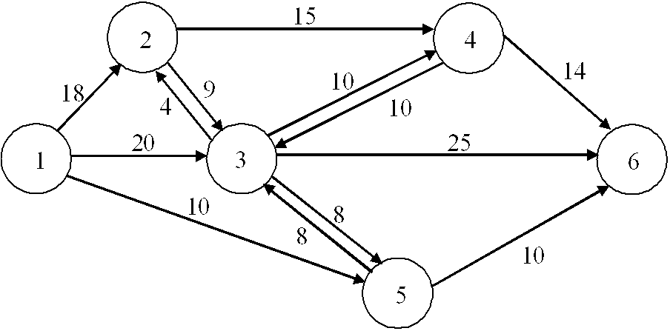

**Question: What is the maximal flow through this network?**

Define the decision variables, the objective function, and the constraints within your answer to this question in your Word report. Then, solve the model using Excel Solver and list the value of the objective function and the values for the decision variables in your Word report.