- Of the molecules below, select those that are paramagnetic.
It may be useful to draw a molecular orbital energy diagram and to fill in the electrons for each molecule.

Li2B2N2CN−O−2O2−2

- Give the bond order of each diatomic molecule. Your molecular orbital energy diagrams from the previous question may be useful.

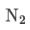

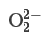
unanswered

3.) BF3 is also trigonal planar.

- Select the appropriate structure for BF3: B, F por (ep)
- Next, place the appropriate atoms into your structure using the internal drop-down menus. If you are using electron pairs in your structure, they can be noted with (ep).

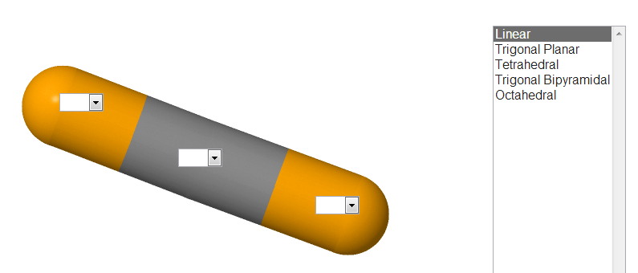

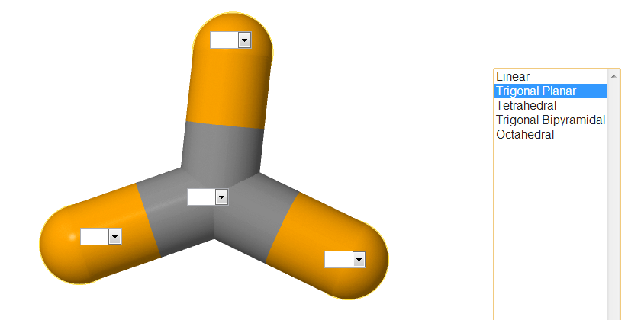

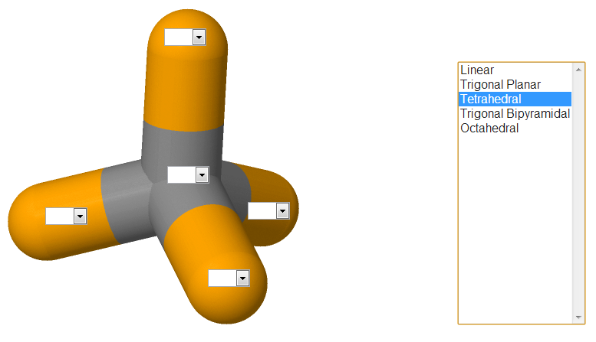

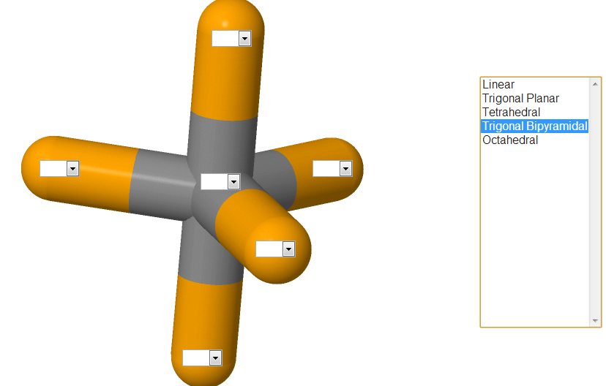

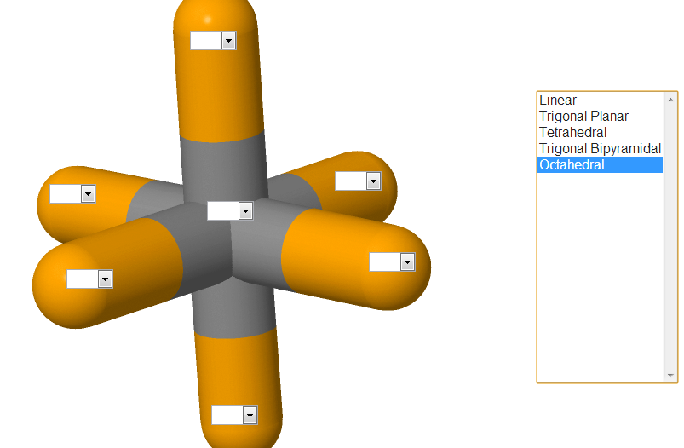

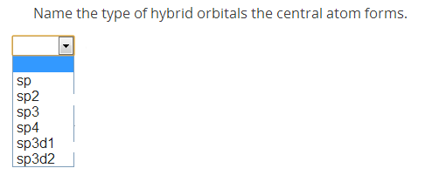
a)

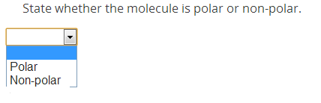
b)

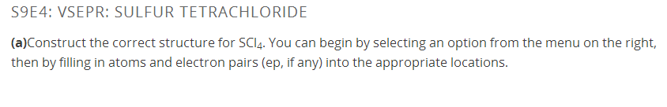
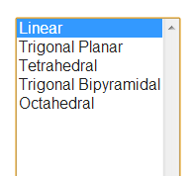

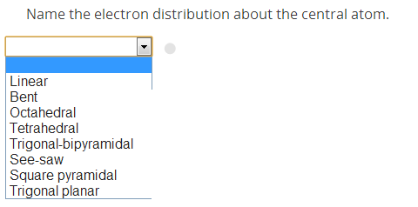
- a)

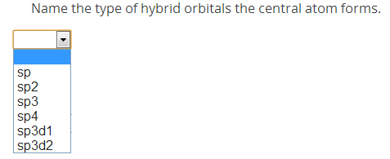
b)

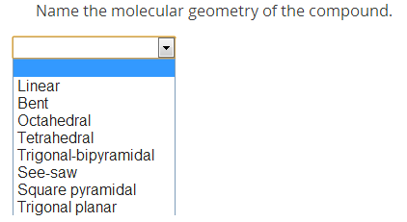
c)

d) State whether the molecule is polar or non-polar.

