Problem 1
A graphical representation of a linear program is shown below. The shaded area represents the feasible region, and the dashed line in the middle is the slope of the objective function.

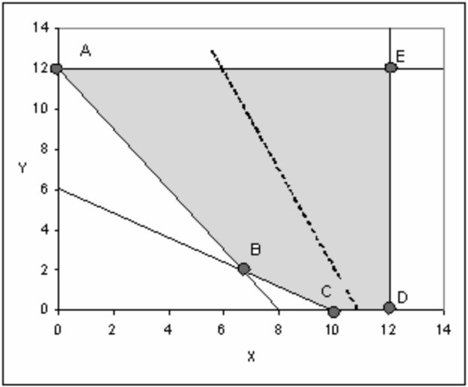

Problem 2

Bullseye Shirt Company makes three types of shirts: Athletic, Varsity, and Surfer. The shirts are made from different combinations of cotton and rayon. The cost per yard of cotton is $5 and the cost for rayon is $7. Bullseye can receive up to 4,000 yards of cotton and 3,000 yards of rayon per week.

The table below shows relevant manufacturing information:
Shirt | Total Yards of fabric per shirt | Fabric requirement | Minimum weekly contracts | Maximum Demand | Selling Price
Athletic | 1.00 | at least 60% cotton | 500 | 600 | $30
Varsity | 1.20 | no more than 30% rayon | 650 | 850 | $40
Surfer | 0.90 | As much as 80% cotton | 300 | 700 | $36

