A restaurant chain operation is interested in determining whether the mean per customer purchase differs by day of the week. To test this, they have selected random samples of customers.

Using the information in the table above:
Describe and give the formula for each of the following, which are used in performing the one-way ANOVA.
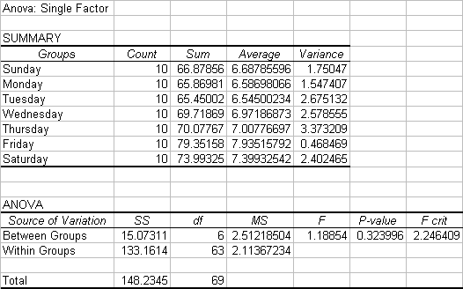
a. Total sample size, n
b. Grand Average, X
c. Between-sample variations and its degrees of freedom
d. Within Sample variation and its degrees of freedom
e. F Statistic and its degrees of freedom
f. F table

