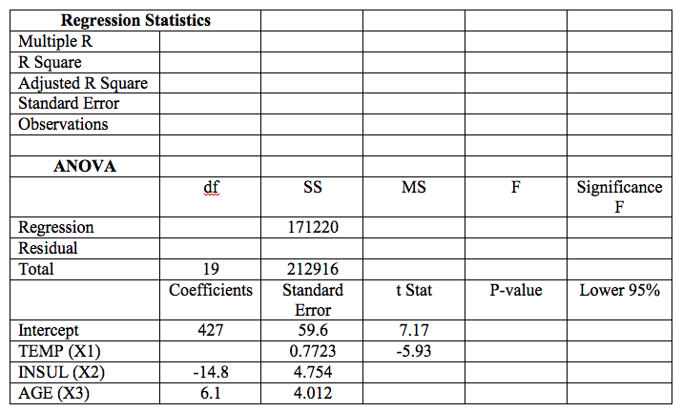
- The value of R-Square is?
- The observed or computed F-value is?
- The estimate of the coefficient b1 is?
- What is the P-Value?

