The objective of this activity is to identify graphs of functions. Select one of the graphs (A-J) and identify the correct equation (1-10) that matches the graph. Identify the slope and intercepts, if appropriate. If not, explain why.
- Correctly identify the equation to the graph.
- Identify the slope and intercepts, or explain why these do not exist for the graph/equation.
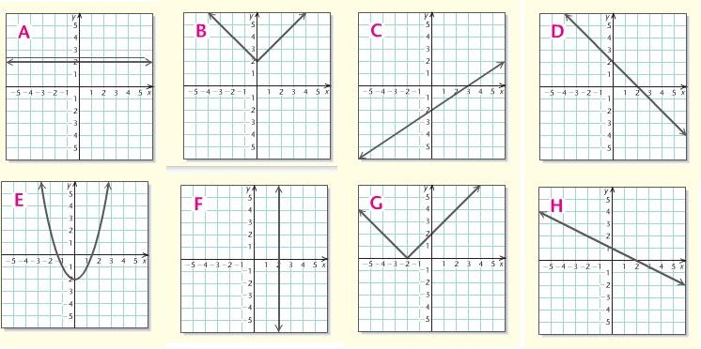
Graphs:

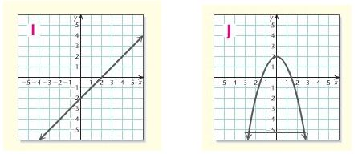

Equations:
