The problem
A healthcare firm’s investment of $1,000 in a piece of equipment will reduce labor costs by $400 per year for the next 5 years. Thirty percent of all patients seen by the firm have a third-party payer arrangement that pays for capital costs on a retrospective basis. Thirty percent of all patients also reimburse for actual operating costs. What is the annual cash flow of the investment? Assume a 5-year life and straight-line depreciation.
Answers :
The cash flow of the equipment investment by the healthcare firm will be equal to the annual reimbursed depreciation plus the reduced operating costs net of the cost reimbursement effect and may be calculated as follows:
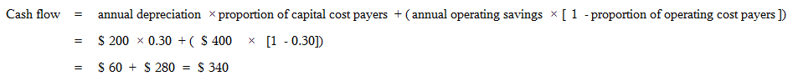

Question I need help with is:
What issues need to be taken into consideration in determining which is the lowest cost alternative?
The example answers only needs to be short no more than 300 word.

