Write the claim mathematically and identify Hₒ and Hₐ. (b) Find the critical value(s) and identify the rejection region(s). (c) Find the standardized test statistic. (d) decide whether to reject or fail to reject the null hypothesis.
A medical researcher says that at least 24% of adults are smokers. In a random sample of 160 adults, 22.5% say they are smokers. At ἀ = 0.01, do you have enough evidence to reject the researcher’s claim?
- Which of the following correctly states Hₒ and Hₐ?
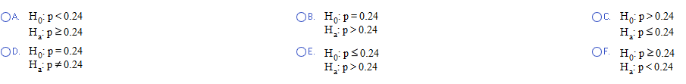
- What is (are) the critical value(s) z ₒ?

z ₒ = _____ (use a comma to separate answers as needed. Round to two decimal places as needed)
Which of the following graphs has the rejection region(s) shaded correctly?
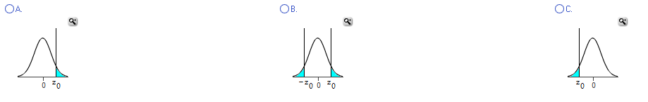
- What is the standardized test statistic? z = _____ (round two decimal places as needed)

- Which of the following is the correct conclusion for the test?
___Reject Hₒ. There is enough evidence to reject the claim that at least 24% of adults are smokers.
___ Reject Hₒ. There is not enough evidence to reject the claim that at least 24% of adults are smokers.
___ Fail to reject Hₒ. There is not enough evidence to reject the claim that at least 24% of adults are
smokers.
___ Fail to reject Hₒ. There is enough evidence to reject the claim that at least 24% of adults are
smokers.

