Develop a worksheet simulation for the following problem. The management of Madeira Manufacturing Company is considering the introduction of a new product. The fixed cost to begin the production of the product is $30,000. The variable cost for the product is uniformly distributed between $16 and $24 per unit. The product will sell for $50 per unit. Demand for the product is best described by a normal probability distribution with a mean of 1200 units and a standard deviation of 300 units. Develop a spreadsheet simulation similar to Figure. Use 500 simulation trials to answer the following questions:
Figure
EXCEL WORKSHEET FOR THE PORTACOM PROBLEM

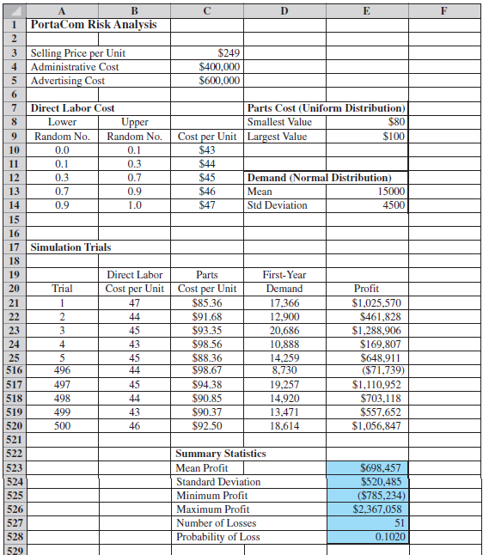

a. What is the mean profit for the simulation?
b. What is the probability the project will result in a loss?
c. What is your recommendation concerning the introduction of the product?

