In Special Education using the following reference to the concept (and with other resources) answer the following questions. Please give references .

Being able to break a task into its constituent parts and identifying what skills will be needed to complete a curricular activity is an important part of modifying curriculum for special needs students. The formal process for performing this function is referred to as a task analysis.
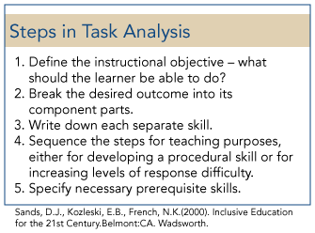
Reflecting on your Misunderstood Minds Web research, complete the following:
- Analyze the purpose of a task analysis for special education students in relation to teaching reasoning, problem solving skills, study skills, organizational skills, and coping skills.
- What two specific tasks that you would like to teach. Please describe your two tasks and create a task analysis for each of your two tasks showing the component parts that students would actually do for each task. Be sure to create specific, observable steps for each task analysis.
- Using Bloom's Taxonomy; analyze your tasks and apply all levels of the taxonomy as appropriate for your tasks. (use the revised version of Bloom's Taxonomy, which can be found easily online).
- How does each level of Bloom's Taxonomy applies to your tasks, and how would you demonstrate how you would try to move your students through the levels of the taxonomy toward higher levels of thinking.

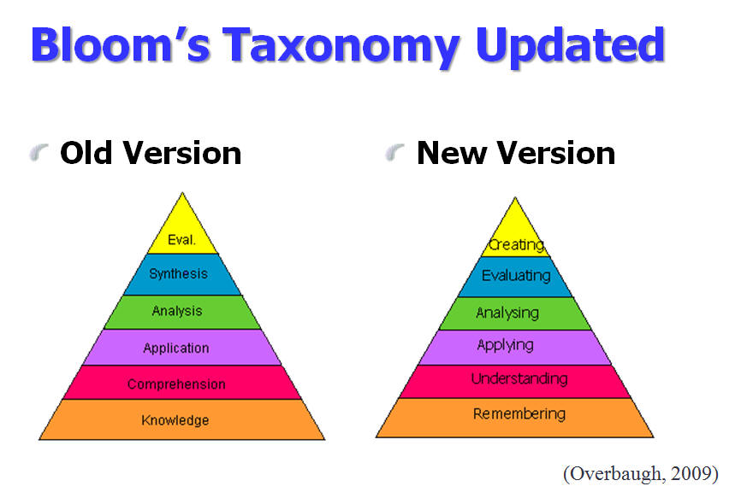

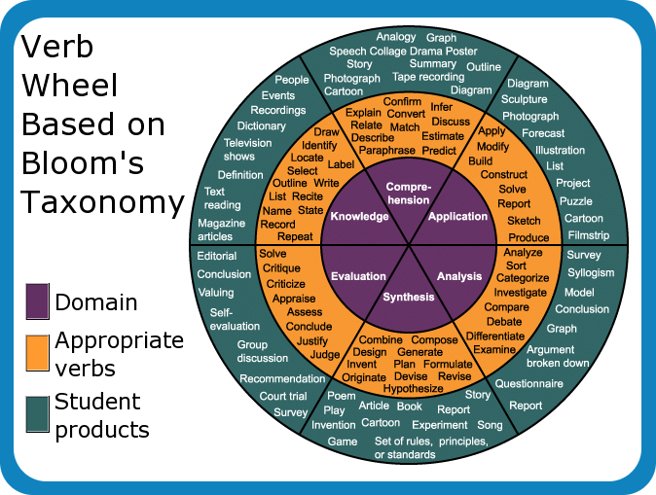
- How do we modify each task for a student whose primary language is not English?
- What particular steps did you take and why?
- Did you find anything challenging about doing this? Explain.

