10. Construct the 95% confidence interval for B and M, of the regression line y = Mx + B, for the population using the following inequalities and data. Use the below data, and complete parts a and b.
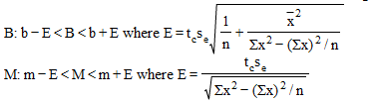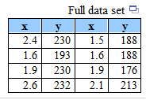
- Construct the 95% confidence interval for the population y-intercept, B.
___ < B < ___
(round to three decimal places as needed, round all intermediate values to three decimal places as needed)
- Construct the 95% confidence interval for the population slope, M.
___ < M < ___
(round to three decimal places as needed, round all intermediate values to three decimal places as needed)

