Assignment Name: | Unit 1 Individual Project
Deliverable Length: | Database and query file, zipped
Details: | Use SQL Management Studio to create a database called ITCO630_P1.MDF. Be sure to store the database in a location that you will remember. Add the tables and data shown below to the database. Use the appropriate field types and lengths for the tables.  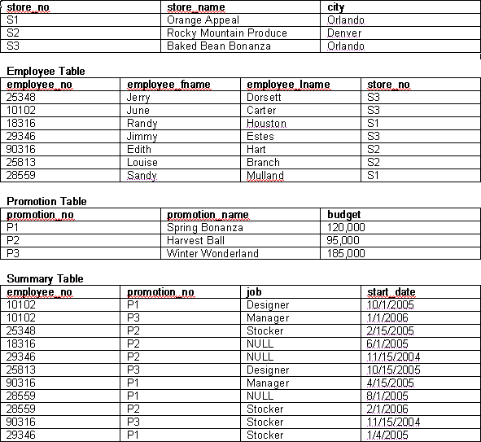  Create the following queries and save them all in a file called ITCO630_P1.SQL. Please note that you can execute individual queries in a query file by highlighting the lines that you want to execute before running the script. Define what database to use with a USE statement.  - Get the full details of the employee table.  - Get the full details of the employees who work in store S2.  - Get the full details of the promotions with a budget greater than $100,000.  - Get the employee number and promotion number for employees with unknown (NULL) jobs who work on promotion P2.  - Using a subquery, get the first and last names of the employees who work in the Orange Appeal store.  - Using a subquery, get full details of all the employees whose stores are located in Orlando.  Detach the database and create a zip file called ITCO630_P1.ZIP including the associated log file and the query file. After creating the zip file, reattach the database.  Please submit your assignment.  For assistance with your assignment, please use your text, Web resources, and all course materials.

