Below are notes from my instructor telling how he wants us to approach the problems. Please show step by step & in the way that we are expected to in class. There are 5 problems in this problem set. Thanks very much. I really appreciate all your help thus far.
16 Local Extrema and Inflection Points

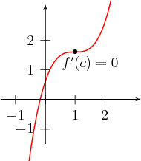
is a critical number, yet no minimum nor maximum there. |  | Critical numbers are necessary but not enough for local extrema  As illustrated in the figure below not all critical numbers give rise to local minima or local maxima. The function has a critical number () and yet it does not have a local extremum. This is because to the left of increases and it continues increasing to the right of .  In order for a critical number to be a local extremum, in addition to , must change its monotonicity at (decreasing to the left of and increasing to the right of , or the other way around).  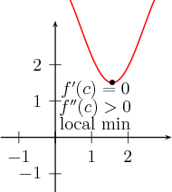  Note that being the slope of the tangent line is negative for  and .

Example -- Second derivative test

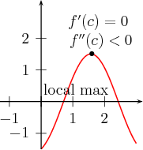
Sometimes at a cricital number , it is not difficult to find the sign of .

For example, let
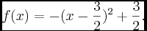
Then , and thus the critical number . , so also . Thus since has a local maximum at .
Example -- First derivative test

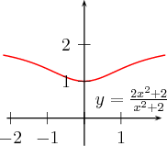

If it is difficult to compute or if , then we investigate if the sign of changes at .
For example, let
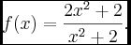

Since is a fraction, its first derivative is already more complicated. The second is even more complex. Check that
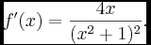
To get a critical number we solve and obtain to be the only critical number. Note that since the denominator of is always positive, if , and if , . Thus the critical number gives rise to a local maximum.

 | Example. To the left of the function is convave down as for . To the right of , the function is concave up since for . Hence, at the graph of has an inflection.  Concavity and inflections  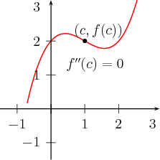  Example. To the left of the function is convave down as for . To the right of , the function is concave up since for . Hence, at the graph of has an inflection.  Recall that the concavity of a function can be determined by the sign of the second derivative . The graph of is concave up when and it is concave down when . If at the function changes its concavity, then we have call is an inflection point for . Certainly, in this case . To ensure that the a number for which gives rise to an inflection, we need to check that changes its sign at | Concavity and inflections  changes its sign at .

Homework
2. (2--6) Determine the intervals on which the function is decreasing and increasing and then find local minima and maxima.
3.
4.
5.
6. The graph of is located below the X-axis but it touches the -axis at . What can you say about the graph of ?

.

