HWU4-22

QUESTION:

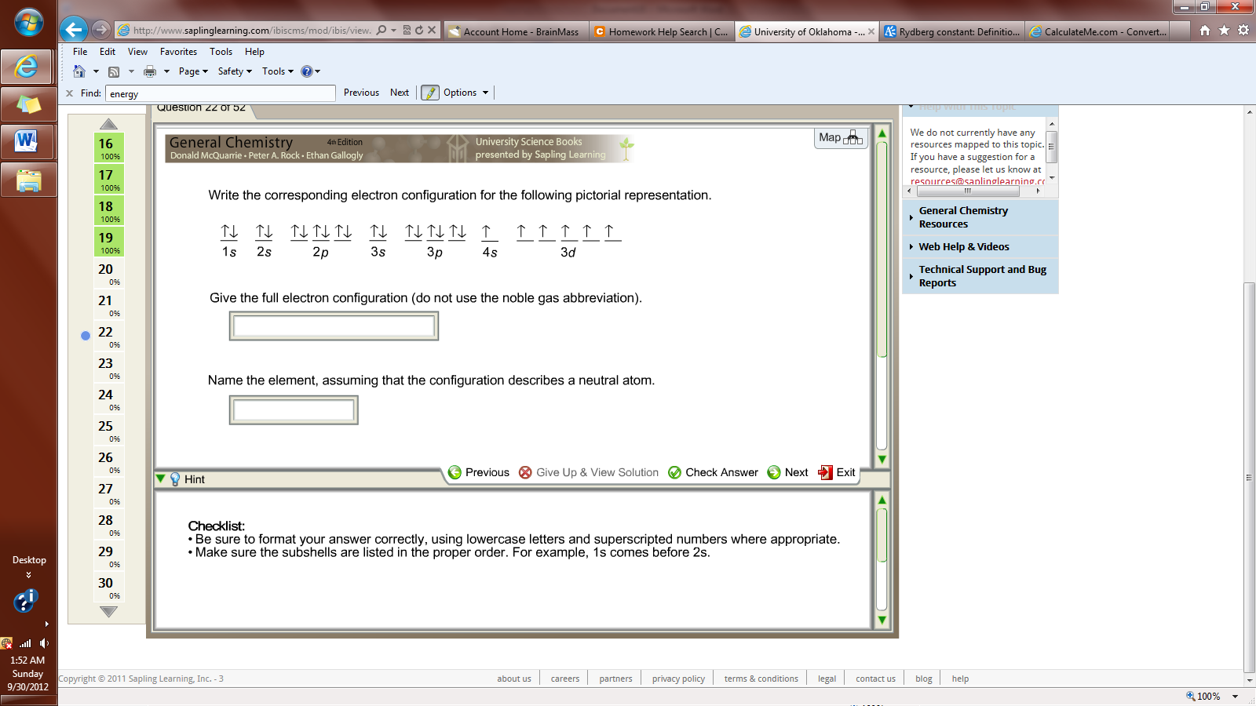

HINT:

Checklist:

•Be sure to format your answer correctly, using lowercase letters and superscripted numbers where appropriate.

•Make sure the subshells are listed in the proper order. For example, 1s comes before 2s.