1.

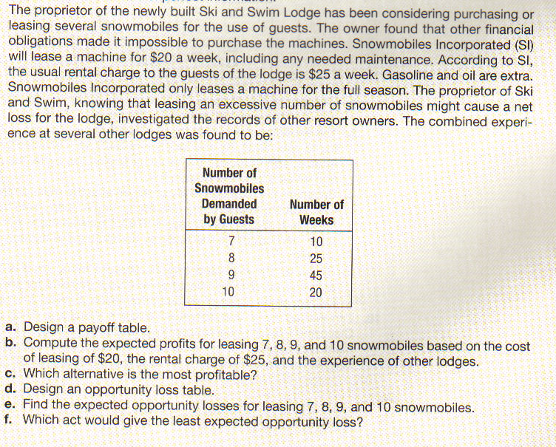

G. Determine the expected value of perfect information.
H. Suggest a course of action to the proprietor of the Ski and Swim Lodge. Include in your explanation the various figures, such as expected profit.

2.


