Geometry has many practical applications in everyday life. Estimating heights of objects, finding distances, and calculating areas and volumes are commonplace. One of the most fundamental theorems in geometry, the Pythagorean Theorem, allows us to make many of these calculations. The Pythagorean Theorem states that the square of the hypotenuse of a right triangle is equal to the sum of the squares of the other two sides, as shown in the diagram below.
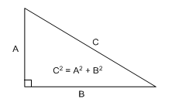
The problems in this Unit will give you an opportunity to practice these applications.
Solve the following problems and submit them in a Word document.
1. A Little League team is building a backstop for its practice field. It is made up of two right angles as shown below. The backstop extends 24 feet 8 inches out in each direction and the center pole is 6.5 yards high. All sides of the backstop including base and the center pole are to be made of aluminum tubing. How many feet of tubing should the team buy? How many square feet of the backstop must be covered by a screen?
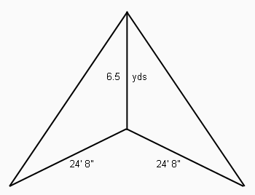
2. An Indian sand painter begins his picture with a circle of dark sand. He then inscribes a square with a side length of 1 foot inside the circle. What is the area of the circle?
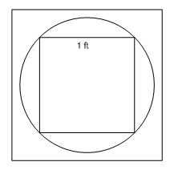
3. Three buildings abut as shown in the diagram below. What are the dimensions of the courtyard and what is the perimeter of the building?
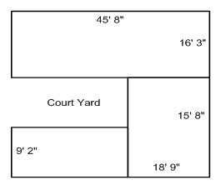
4. A cylindrical can is just big enough to hold three tennis balls. The radius of a tennis ball is 5 cm. What is the volume of air that surrounds the tennis balls?

