Questions:

1. Please describe in detail each of the wells (1-8) in the electrophoresis picture below? (There are 2 gels below. One of the gels in incorrect and one is correct. Please select the correct gel and describe each of the wells (1-8) in detail).

2. Describe the results of the albumin purification including a description of the relative mobility of the purified protein? Did the affinity chromatography column remove all of the albumin from the serum? How pure was the affinity isolated protein?

3. What would be a good title for this experiment?

Gel 1
Wells 1 2 3 4 5 6 7 8

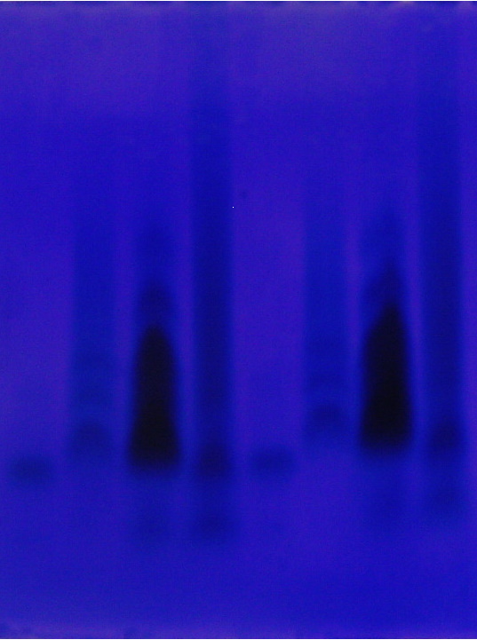
-

+

+

Gel 2

Wells 1 2 3 4 5 6 7 8
-

+


