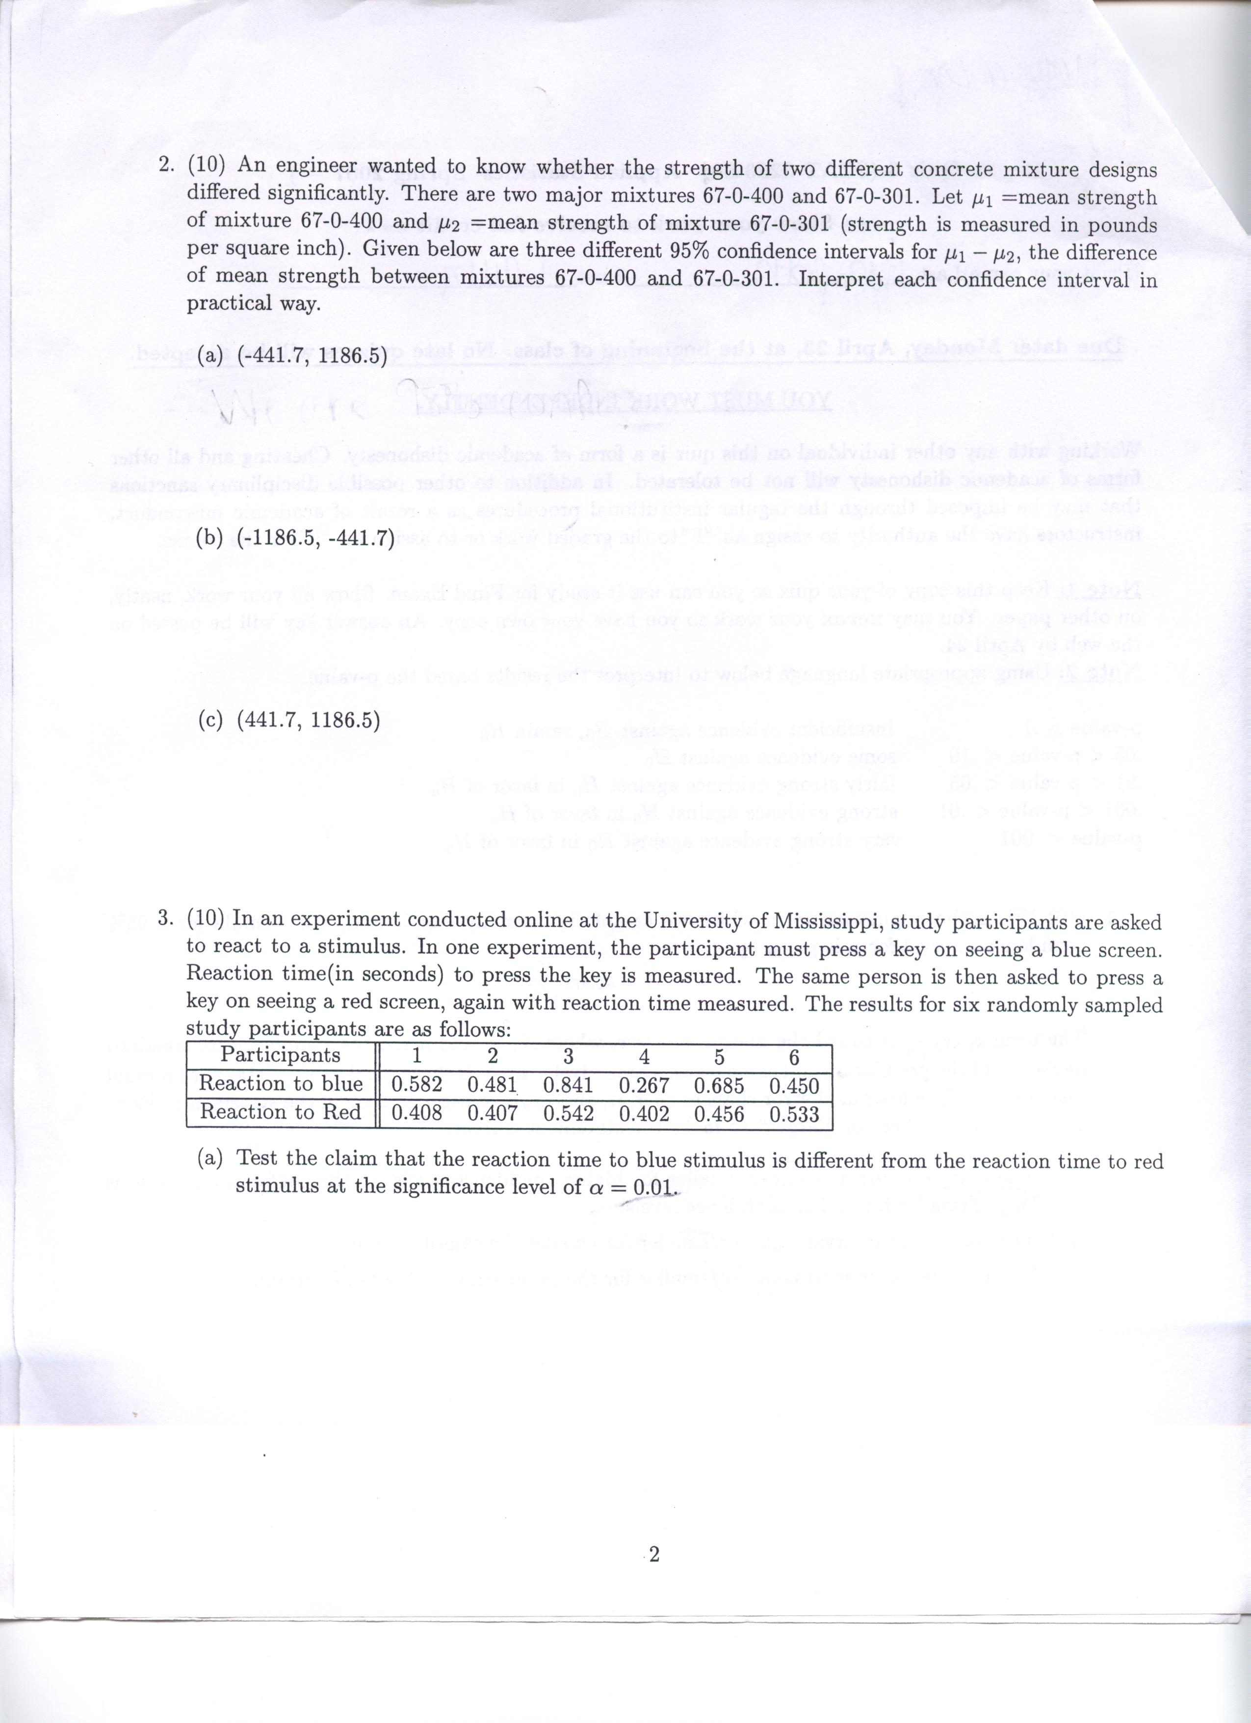
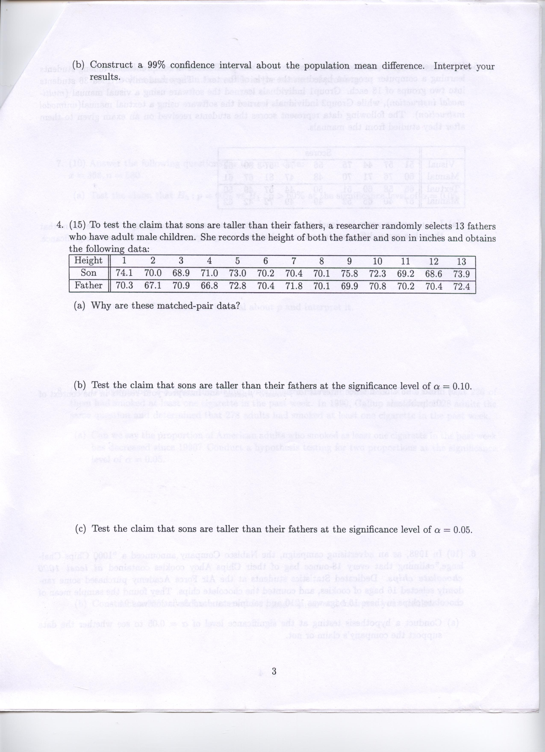

The Baldwin Sisters from the Walton's TV series had a family recipe for moonshine (a strong, home-distilled alcoholic beverage)? Anyway, the Sister's made a slight modification in their father's recipe for moonshine. They conducted a test of taste preference between the new recipe and father's recipe. One hundred and thirty of the town folk participated in this moonshine taste test. Consider the following questions about binomial probability.
14. If there was no preference between these two recipes, how many town folk would you expect on average to select the old recipe
Mean____ Standard Deviation_____

15. As it turned out that nippy Virginia afternoon after Thanksgiving, eighty five of the town folk preferred the new recipe for moonshine. If there really was no preference between the two recipes, what is the probability that eighty five or more people would choose the new recipe by chance ?
_________________%

