2) The graph shows the variation of the water level relative to mean sea level in Commencement Bay at Tacoma, Washington, for a particular 24-hour period. Assuming that this variation is modeled by simple harmonic motion, find an equation that describes the variation in water level as a function of the number of hours after midnight.

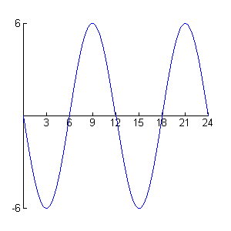
Noon
Midnight
Midnight
Mean
Sea Level
(feet)

