The director of social services of a county has learned that the state has mandated additional information requirements. This will place an additional burden on the agency. The director has identified three acceptable alternatives to handle the increased workload.

One alternative is to reassign present staff members, the second is to hire and train two new workers, and the third is to redesign current practice so that workers can readily collect the information with little additional effort. The director of the social services indicated that reasonable caseload probabilities are .20 for moderate, 0.30 for high, and 0.50 for very high. The estimated costs (in $ thousands) for various options and caseloads are shown in the following table.
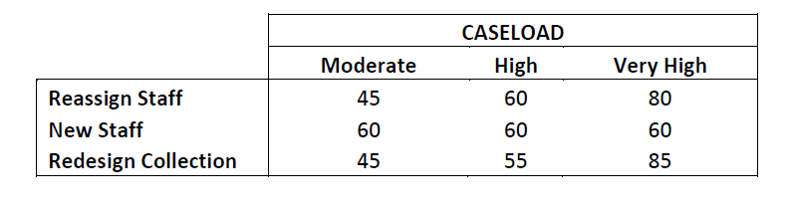

a) Draw a decision tree for this problem.
b) Which alternative will yield the minimum expected cost?

