A total of 5,000 people live in Acaville. There are 1,000 high school students, 1,000 undergraduate students, 1,000 graduate students, 1,000 economics professors, and 1,000 retired economists. Suppose that the total annual income in the economy is $100 million: each high school student makes $2,500 annually; each undergraduate makes $15,000 annually; each graduate student makes $25,000 annually; each professor makes $50,000 annually; and each retiree makes $7,500 annually.
The chart below shows the income distribution for the town of Acaville.
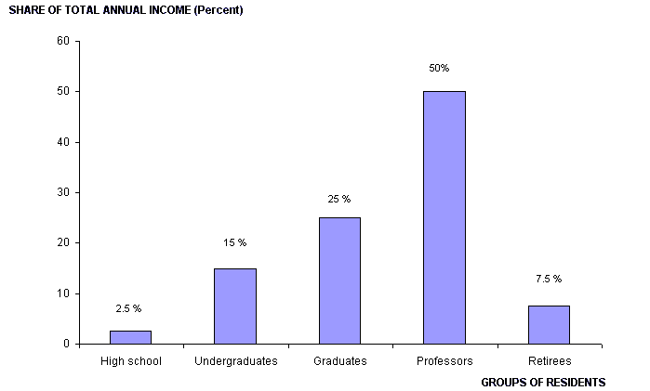

 |  | 4.2. | Which of the following correctly orders the people of Acaville from the bottom fifth to the top fifth of income distribution?
 |  | A. | High school students, retirees, undergraduates, graduate students, professors
 |  | B. | High school students, undergraduates, graduate students, professors, retirees
 |  | C. | Graduate students, professors, high school students, undergraduates, retirees
 |  | D. | Retiree, graduate students, undergraduates, high school students, professors

