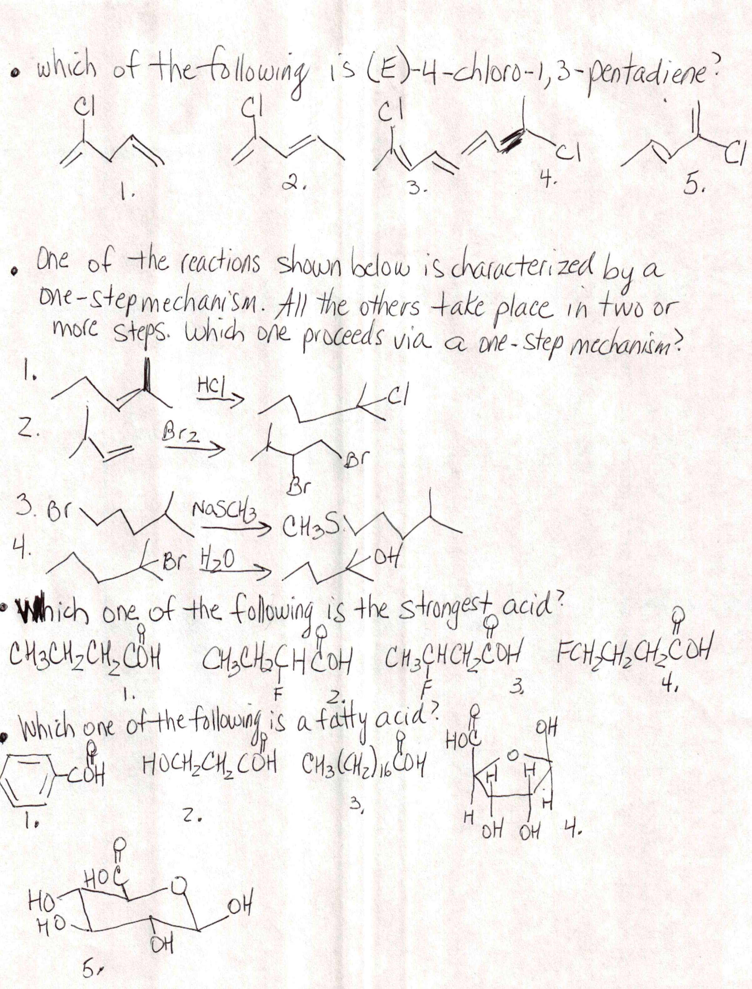
- How many possible trisubstituted derivatives C6H3X2Y can be btained from the meta disubstituted benzene C6H4X2? (Ignore directive effects of the substituents X and assume that all positions on the ring are accessible to the reagent Y+).
- One 2. Two 3. Three 4. four

- In assigning priorities according to R,S convention, which group ranks highest?
- –CH2(CH2)10CH3
- –CH(CH3)2
- –C(CH3)3
- –CH2Cl
- –CH2(CH2)10Cl

- Which of the following compounds reacts with cyclopentanone to yield and amine?
- NaNH2
- (CH3)2CHNH2
- (CH3)3N
- (CH3)2NH

- In a strongly acidic solution the amino acid lysine exists as the dication:
+
H3N(CH2)4CHOOH
⏐+
NH3
As the pH is raised what monocation is formed from the loss of the proton from the dication?
O
⏐⏐
- H2N(CH2)4CHC OH
⏐
+ NH3

O
+ ⏐⏐
H3N(CH2)4C OH
⏐
NH2
3.
O
+ ⏐⏐
H3N(CH2)4C OH-
⏐
+NH3
4.
O
+ ⏐⏐
H3N(CH2)4C OH
⏐
+NH3

