CHAPTER 12 Early Care and Education Programs as Community Resources
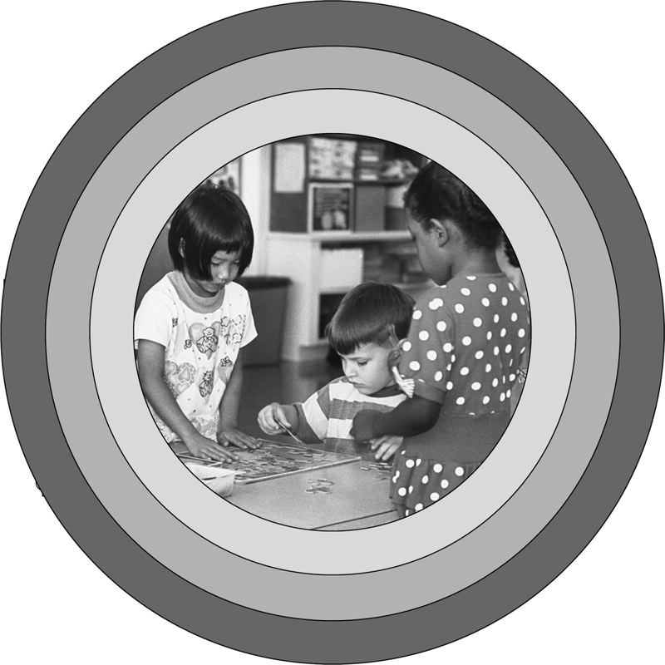
In this chapter you’ll discover …
♦ Why early care and education programs can be considered child rearing
♦ Three things that influence quality in early care and education programs
♦ Some arguments about breaking large centers into small groups
♦ Some ideas about bridging the gap between early care and education programs and home
♦ How to help parents gain a sense of community in early care and education programs
♦ Some roadblocks to respect between parents and teachers
The last chapter looked at six different families who were all participating in early care and education programs at the same center. This chapter gives an overview of the different kinds of early care and education programs and their benefits to children and families. It also looks at some of the issues around providing full-time child care to working families.
Early care and education programs are difficult to explain to anyone who hasn’t experienced them. They go by different names, serve different age groups, and occur in a variety of settings. The first three years of elementary school, the primary grades 1–3, fall under the category “of early care and education” because developmentally the children are more like their younger peers. They make a developmental shift around the time they leave third grade into what has been called “the age of reason.” By fourth grade most children are cognitively ready for what can be thought of as more traditional schooling. The developmental perspective is that children have different needs in each stage of development. (Chapters 2–5 focused on working with parents during each of the various developmental stages.)
Kindergarten is in a category by itself because it isn’t quite school, but it isn’t preschool either. Kindergarten was started in the United States because some wise educators saw the need for a transition for children instead of sending them from home directly to school. Kindergarten was designed to ease children into the routines and behavior expected of them when they entered first grade. Kindergarten now seems to be more of a first grade, and preschool has become the transition period.
Child care for school-age children is also in a category by itself and has the unique feature of often including children who are no longer in their “early years.” A variety of programs support families who need to have a safe environment and supervision for their school-age children during the hours they work, when their children are not in school. In addition to having educational, developmental, and caring elements, school-age care also has important socialization functions as children learn to get along in groups of their peers in less structured programs than school usually offers. School-age care often comes in the form of “surround care” where children leave home before school, spend an hour or more in child care in mixed age groups, then go to a classroom where the children are all the same age. After school they go back to the child care program. During school holidays and summer vacations, surround care becomes full-day care to meet the needs of working parents. These programs take place in a variety of settings including homes with family child care providers. If programs are run by schools, they are often in portable buildings on the school grounds, or sometimes in a multipurpose room. Some school-age programs are standalone programs that serve only children from kindergarten up. They may be privately owned or publicly funded. They may be in their own building or in a rented space. Other school-age programs are part of a comprehensive child care program serving children from birth to 12 years of age. Usually in those programs, the younger children are separated by age, while those in the school-age population are put together in mixed age groups.
The most well known of the early care and education programs is the preschool program. The term preschool is confusing because it brings up different pictures for different people. Preschool merely means “before school.” Another term for it is prekindergarten, or pre-k. In the past, the preschool program was commonly called nursery school, which is the term I prefer because it emphases the nurturing part. I was on a campaign for awhile to spread the term nurtury since nursery school is so old fashioned. But with all the push for readiness and academics, I missed out, so now I just use preschool, even though it annoys me that early care and education programs have to be pre anything. It seems to me that they are an institution in their own right—just as children are children—not preadults.
So what does the term preschool encompass? It includes half-day programs such as Head Start and other compensatory programs for low-income children. When I first entered the early care and education field in the 1960s preschools were half-day programs for stay-at-home mothers, who were mostly middle-class housewives. Head Start was begun for a whole different segment of the population. Day care, as full-day programs were called then, was for single mothers who worked, or families with two working parents. Some were run by school districts, and some still are.
Infant–toddler programs were separate and apart—and to some extent they still are. Back in the 60s when I was a preschool teacher, I worked in a parent involvement program. The children were in preschool, the parents in English as a Second Language classes, and the babies were in a “nursery” with a group of untrained volunteers “watching” them. The first programs for infants with trained staff were early intervention programs for children with special needs. Infant care for working families was mainly done by family child care providers.
That’s another form of early care and education: family child care. Those programs were, and still are, conducted in private homes by the people who live there and represent the largest service providers for working parents in the United States. Over the years these programs have become part of the regulating system. In many states the programs are licensed, and in some the individuals working in them are trained as well. States vary a great deal in how much attention is paid by government workers, funders, and policy makers to family child care providers.
Though family child care may be looked down on by those early educators who consider themselves more professional, family child care programs have a lot going for them. As a consumer of family child care, I’ve always been aware of the advantages. Usually parents have more choices when it comes to family child care programs. Homes, necessarily (and often by regulation), have smaller groups of children than programs outside the home. Providers can develop personal relationships easier with children and their families. Continuity of care, an important component of children’s early experiences, is more likely to be available in family child care. That means that children can stay in the same home from infancy until the time they don’t need the service any more. Of course that doesn’t always happen, but it’s possible, whereas in most out-of-home programs children change classrooms, teachers, and sometimes groups every year or even more often.
In the days when I started in the field preschool and child care were separate entities, and preschool was considered educational while child care was considered custodial. That doesn’t necessarily represent reality, but rather the image many people both inside the field and outside it carried in their heads about the distinction of the two. Some still see the two as separate, but others, such as myself, have been working hard to help everyone see the link between care and education and to quit separating programs by types.
In Australia, where I have traveled quite a bit, a simple descriptive title distinguishes the two. Children go to “sessional programs” or to “long-day programs,” and the whole field is called children’s services, which connects everything rather nicely. We, in the United States, are still working at these connections.
The reality is that if staff is well trained, if the groups are appropriate sizes for the ages of the children, and if the environment is set up appropriately to promote development, learning, and caring, any program can provide both care and education—whether the program is part-day in a school following an academic calendar or all day, year round, and whether it is in a separate facility or in someone’s home. Good quality care and education don’t just happen accidentally—there are lot of people and organizations working hard to make sure that every child has the opportunity to be in a setting that provides both good care and education. We’re not there yet, but we’re working on it.
Making the link between care and education hasn’t been easy. What has helped is that Nell Noddings, a Stanford professor has written several books making a good case for always having a connection between care and education all the way up through the university. She wrote a book called The Challenge to Care in Schools (2005) in which she described how public schools, from kindergarten up can have a caring curriculum that is educational. She sees a caring curriculum as vital to moral development, a hot topic among families and educators these days. As I read her book, I was anxious to tell her that she was describing what we already do in early care and education programs. So I wrote her a “fan” letter and got a very nice reply! I’ve never written a fan letter in my life.
Universal pre-k, sometimes called preschool for all (or PFA) is a movement that is gaining momentum. Advocates want to assure that every four year old has a chance to attend a free half-day preschool. Though universal pre-k looks different in different states, that’s the main push behind it. Some states have already succeeded in instituting the change, while others are still investigating it. According to ExhangeEveryDay (an online child care newsletter delivered through e-mail June 12, 2007) all but 11 states are in various stages of at least discussing universal pre-k. According to Morgan and Nadig (2007) there is no standard way to institute universal pre-k. Some states are creating a class before kindergarten in the public school system, while others are considering free education for 4-year-olds in a variety of settings. Still others are targeting low-income famlies for free education for their 4-year-olds. There are different ways to look at universal pre-k at this stage of the game (see Figure 12.1).
As the number of child care and education programs continues to increase, many are asking the question: Who is rearing America’s children, and how are they being reared? That is an increasingly compelling question. It was a nonquestion just a generation or two ago, because America’s children were mostly reared by their own parents, or by specific substitutes whom the parents designated. Child rearing belonged to the family. Business, education, and government mostly stayed out of the picture, except for a brief period during World War II and except for protective and remedial reasons.
Figure 12.1 Some Ways to Look at Universal Pre-K
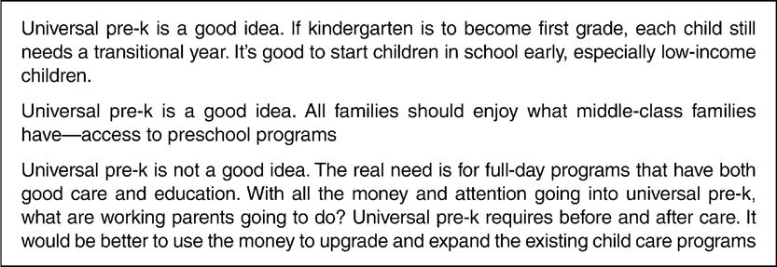
Today the picture has changed. The number of single-parent families in which the parent trains or works outside the home is steadily rising. And in a majority of two-parent families, both parents work outside the home (see Figure 12.2). Child rearing is now shared, as families use an array of early care and education services. Furthermore, business and government have become part of the picture.
Figure 12.2 Mothers in the Workforce
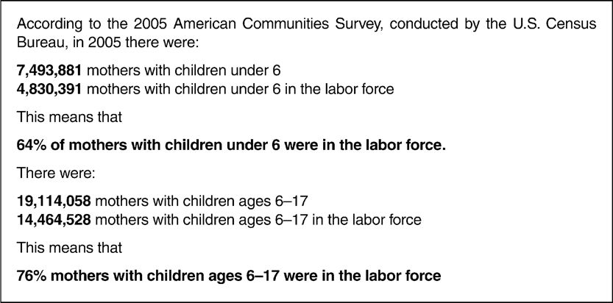
The Child Care Center Licensing Study of the Children’s Foundation in Washington, D.C., indicates that there were 117,284 regulated child care centers in the 50 states, District of Columbia, Puerto Rico, and the Virgin Islands. This is an overall increase of 26 percent since their 1991 study (see www.childrensfoundation.net).
Who is raising America’s children? Perhaps you are or will be—either as a parent or as a professional in the field of early care and education. As the need for services expands and programs struggle to keep up with the need, more and more early educators, such as child care workers, teachers, caregivers, infant care teachers, family day care providers, in-home care providers, and nannies, supplement parent care.
EARLY CARE AND EDUCATION PROGRAMS AS CHILD-REARING ENVIRONMENTS
Why does this text keep equating early care and education with child rearing? After all, the United States doesn’t have a communal child-rearing system in which children are taken out of the home and socialized into a model consisting of a single set of ideals. We don’t believe in social or political indoctrination for our children. Child rearing is an individual matter of individual families and always has been. As a society, Americans agree to disagree. Diversity has always been a key theme as well as a strong point of America’s people. Families want to rear their children in their own way. However, these days individuals and families must look outside themselves for supplements to what they can provide. They can no longer do all the child rearing themselves.
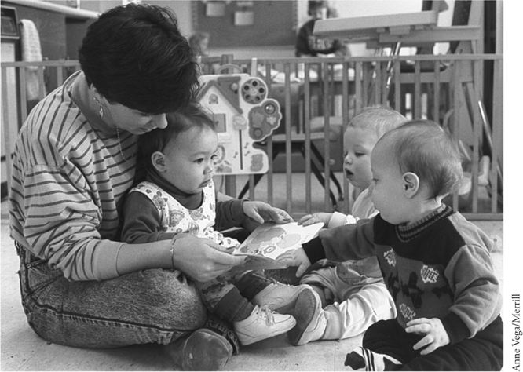
You can’t park your children like your car. Children need to be in an environment where they can grow and learn.
But is child care really child rearing? Yes. You can drive your car to work, park it in a garage, and come back and pick it up in the afternoon, and, except for a new layer of dust, it is almost always in the same condition you left it in. You can even leave your car at home in the garage, take the bus or the train to work, and come back and find it just as you left it.
But you can’t park children. Wherever children are, they are growing and learning, being changed by their experiences. They are being reared. How they are being reared is a big question. They can be reared in accordance with parental expectations and values, or they can be reared in ways that are quite contradictory.
The challenge for our society in these times is to offer enough choices so that parents can find programs in tune with what they want and need for their children. The choices could include both nonparental care solutions such as out-of-home early care and education or in-home care, as well as creative alternatives that allow working parents a greater role in caring for their own children. Flextime, one of these alternatives, allows parents to stagger their work schedules to be with their children, thereby doing the child rearing mostly themselves. Part-time work also allows more parental involvement in child rearing; job sharing is one way to become a part-time worker. In some countries, workers are subsidized to stay home with their children instead of working a full day or a full workweek. Flexible benefits plans and flexible leave and transfer policies can also be creative alternatives that allow parents to spend more time with their children.
Worthy Wages and Quality Care
Kayla is in a quality child care center with a stable staff who know her well and can provide just the kind of care and education she needs. Staff members are sensitive and well trained, and they have the time and energy to arrange the environment in appropriate ways and to set out a variety of interesting and worthwhile activities that promote growth and development. They are there to guide, protect, and teach Kayla by relating to her on an individual basis and by supporting her development in numerous ways. Kayla is happy in her school, and her mother is happy that she is there. But what about the teachers?
If the teachers are happy, it’s because they love teaching and work in a well-funded program in which they are paid what they deserve, have a good benefit package, and have adequate support through staff and other resources. Or perhaps they are happy because they have other sources of income and have figured out how to scrounge up the resources they need. Or they may get so many rewards from teaching that money isn’t an issue with them. Many good teachers remain in the field despite the low pay.
However, in most child care programs, the staff is underpaid, and if any of them are the sole support for their families, they have a hard time managing on a child care teacher’s wages. Child care teachers’ wages reflect their status, which, according to the Bureau of Labor statistics, is equated with parking lot attendants. Some refuse to leave the field, even though they are being paid less than prison guards and animal tenders. These dedicated souls are helping to rear the nation’s children—rearing these children at the point of their lives when they are very impressionable.
What does it mean to children and families that child care teachers are underpaid and undervalued? It means a lot. It means that many people will never even consider going into the field—people who have a lot to offer children. It means that anyone who isn’t totally dedicated to the profession and wants to make an adequate living will look elsewhere. It means that few men, especially those who don’t have a partner who can supplement their income, will look to child care as a career option. This limits the field drastically.
The problem of low status and salary is reflected in the turnover rate (Whitebook & Sakai, 2004). Many people enter the field only to leave it in a short time, when they find the demands of the job too much and the pay too little. One-third to one-half of the people working in child care are new every year. That means that children see their teachers constantly changing—continually coming and going. As soon as they get to know and trust someone, that person leaves. Eventually children stop developing relationships with their child care teachers—it’s just too painful to keep saying good-bye for good.
That’s not good for children.
Quality is tied to status, salaries, and training. Who is going to spend the money for training if the status and salaries are so low?
We are in a crisis situation. We have a great need, as a nation, for early care and education programs. Working in the early childhood education field can lead to a very satisfying career. Yet the money for quality programs just isn’t there. Most parents couldn’t possibly afford what quality care costs. They need subsidies. A few parents get some subsidies from the government; others get them from employers. But an enormous number receive their subsidies from the teachers who are willing to work for so little pay. That’s not the ordinary way to look at subsidizing child care, but it is one way. Don’t you think that it is time things changed?
AFFORDABILITY AND AVAILABILITY
Two A words loom up when we look at requirements for early care and education, especially those for working families: affordability and availability. When we, as a society, work to create both affordable and widespread early care and education programs that meet families’ needs for child care, quality often gets lost. We get into a double bind when we deal with both quality and cost: Most parents can’t afford to pay what quality programs really cost. In 48 states, the cost of center-based child care for a 4-year-old is greater than tuition at a 4-year public college (Children’s Defense Fund, 2004). If you consider that one-third of the families with young children earn less than $25,000 a year, according to the Children’s Defense Fund, you can see that child care costs are beyond what these families can afford. Even when both parents are working, if they work at minimum-wage jobs, together they make less than $25,000 a year. How can they pay for full-day early care and education on their salary?
Child care professionals come out worse than that. They can’t afford child care unless it is provided free where they work. Their average salary is far less than other educators and service workers, according to Whitebook and Sakai (2004). The families who need care most can’t afford it, yet as a society we can’t afford not to pay it, especially for low-income families. Quality costs, but it saves in the long run. Studies show that risk factors associated with cognitive delay and other developmental problems can be lessened by early intervention in the form of quality early care and education programs that meet the needs for child care (Illig, 1998; Karoly, 1998). Furthermore, quality early care and education programs can cut the crime rate. A report prepared by an expert panel convened by Fight Crime: Invest in Kids shows that 989 children who had been enrolled in government-funded child-parent centers as 3- and 4-year-olds cut the risk of problems with the law in their teens. Half as many of the children in the program had arrests in their teens as a similar group not included in the program (Brazelton, Zigler, Sherman, Bratton, & Sanders, 1999).
The North Carolina Abecedarian Project showed that early childhood education can make a critical difference in the later success of poor children. This project was a carefully controlled research design project in which children who had an individualized prescription of educational activities and games as a part of their daily routine tested higher in cognitive test scores up to age 21, achieved higher levels in reading and math, completed more years of education, and were more likely to attend college than children not in the program (Campell, Pungello, Miller-Johnson, Burchinal, & Ramey, 2000).
A study of Head Start called FACES (U.S. Department of Health and Human Services, 2003) showed that the program narrowed the gap between the performances of children from poverty-level families and their higher income peers. Low-income Head Start children showed significant improvement in social skills, emotional development, and behavior, which was linked to their cognitive development. Parent participation in educational activities with their children was positively correlated with children’s behavior and early literacy skills. A different study found that Early Head Start, the program that serves infants and toddlers, also has significant benefits and impacts social-emotional development as well as children’s cognitive and language development at age 3.
As a society we haven’t yet learned the lesson that quality costs but pays off. We aren’t willing to pay what child care really costs. We say we can’t afford it. As a result, early care and education programs, including child care in the United States, aren’t as good as they could be.
Status and Salaries
The Status and salaries of child care teachers are two problems related to quality and cost that haven’t been solved yet. Child care teachers are still underpaid, and a majority receive no benefits. Their salaries put them at the poverty level, and their status puts them in the same category as parking lot attendants. Not a pretty picture! The National Center for the Early Childhood Workforce in Washington, D.C., has been addressing this issue for a number of years. The pattern goes like this: The lower the salary, the higher the turnover rate. The greater the turnover, the lower the quality of services and the more likely for the children to have poor developmental outcomes. In a program with a high turnover rate, the less likely that children will experience responsive care-giving and sensitive interactions (Whitebook & Sakai, 2004).
Imagine the children in a program with a high turnover rate. They are constantly disrupted by changes in their routines. High turnover means that rules switch as teachers come and go. It means that just as the children get to know a teacher, he or she disappears suddenly and is replaced by a new person. Separation issues don’t get resolved. The consistency of the stable environment that children need to flourish is a sought-after vision but seldom a reality.
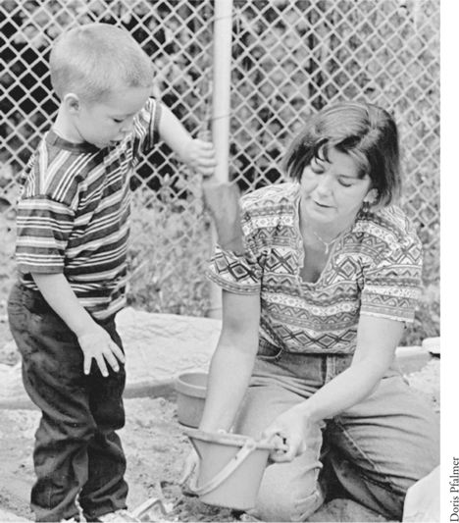
Child care is a necessity for many families.
We need to find ways to solve these problems. It isn’t just up to families and early educators to work toward solutions. Indeed, as mentioned earlier, many parents are paying more than they can afford now. A low-income family can pay as much as 26 percent of the family budget for child care. And teachers, by working for poverty wages, are subsidizing child care themselves. No, it’s not up to parents and teachers to solve this problem alone. It is in the public interest to help also. Children are the future of America.
Even without platitudes, you can look at the situation from a very personal point of view. When you reach retirement age, you will be dependent on a strong, healthy, productive workforce to keep the society and the economy going. You won’t be able to sit back and enjoy the fruits of your own labor if there is no one to carry on.
Even more personally, imagine yourself in a retirement home being cared for by men and women whose own upbringing left much to be desired. If today’s society allows its future citizens to be neglected at home or warehoused in an institutional setting, how well will they treat you if and when you need their care in your old age?
THE STATE OF CHILD CARE IN AMERICA TODAY
The picture of child care is sad. We still have a long way to go. We aren’t yet close to creating a system that fills the need and provides quality care. When President Bill Clinton signed away the traditional welfare system in 1996 and changed it to Temporary Aid to Needy Families (TANF), all of a sudden the need for child care increased dramatically, as former welfare recipients became trainees, and their children, including babies, needed a place to go. Although infants had been trickling into child care for some time, all of a sudden they came pouring into the system at a rate programs couldn’t keep up with. This situation meant that for TANF to work, child care had to expand, which called for more funding to keep up with the demand and more training dollars to increase the child care workforce. We still haven’t met the current need, and a large number of children are in inadequate settings. Families of all income levels still have problems finding quality care, but the problems are worse for low-income families. These families have more at stake also because the consequences of inadequate care plus lack of effective educational approaches tend to be more severe for children of low-income families.
Our system of child care is notable for its diversity, which is both a strength and a challenge. Creating a seamless system that meets the needs of all children and all families is still a distant dream that we are only just beginning to realize. Unlike some smaller European countries, there is no single policy or program that can address the child care needs of all families and children. No single entity or organization can provide child care for the nation, but rather the responsibility for meeting the nation’s child care needs has to be widely shared among individuals, families, voluntary organizations, employers, communities, and government at all levels.
LOOKING AT QUALITY
Defining, measuring, and monitoring the quality of child care are very hard tasks, because to some extent the definition of quality is highly subjective and personal. However, the classic study done in the 1970s—the National Day Care Study (Ruopp, Travers, Glantz, & Coelen, 1979)—came up with three variables that influence quality: group size, caregiver-child ratio, and caregiver qualifications. This study helped justify and substantiate the laws and regulations governing child care. It also helped back up the National Association for the Education of Young Children’s (NAEYC) accreditation criteria, which are now contained in a major instrument to assess quality across the nation. There are 10 NAEYC program standards (found at www.naeyc.org), organized into four focus groups. The first group of standards focuses on children, on what is needed to support their development and learning. The other three groups focus on what is needed to create and maintain excellence in programs and relate to teachers, family and community partnerships, and leadership and administration (see Table 12.1).
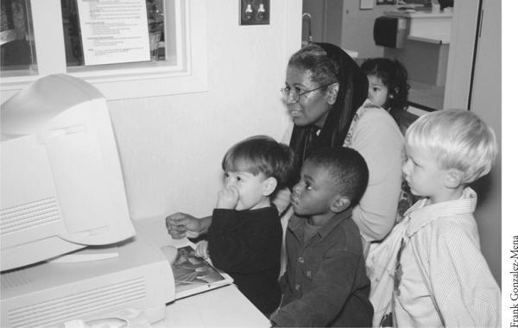
Group size is a variable that influences quality.
Although we continue to move forward as a profession, in many places in the United States child care remains unregulated—and even where it is regulated, laws and regulations provide only a bottom line (i.e., they define minimum standards). Various national and state professional organizations have provided more optimum guidelines, including a book of standards from NAEYC called Developmentally Appropriate Practice (Bredekamp & Copple, 1997) and an updated introductory version called Basics of Developmentally Appropriate Practice: An Introduction for Teachers of Children 3–6 (Copple, 2006).
Table 12.1 NAEYC Accreditation Standards
Focus Area:
Children
Program Standard 1:
Relationships
Program Standard 2:
Curriculum
Program Standard 3:
Teaching
Program Standard 4:
Assessment
Program Standard 5:
Health
Focus Area:
Teaching Staff
Program Standard 6:
Teachers
Focus Area:
Family and Community Partnerships
Program Standard 7:
Families
Program Standard 8:
Communities
Focus Area:
Leadership and Administration
Program Standard 9:
Physical Environment
Program Standard 10:
Leadership and Management
ADULT-CHILD INTERACTIONS IN CHILD CARE AND EARLY EDUCATION SETTINGS
When looking for high-quality settings, an important question to ask is: What is the quality of adult-child interactions, regardless of the program model? Taking into account that the first program standard of NAEYC’s accreditation model relates to relationships, let’s look at adult-child interactions with that in mind.
Most early educators and many parents today would agree that children should spend their days actively involved in exploring and learning about the world and each other. A helpful adult close by is essential for providing resources, input, and guidance. Is that what happens in most child care programs? According to researchers Susan Kontos and Amanda Wilcox-Herzog, academics have only just begun to study how interactions take place and what kind are related to what outcomes in children. In an article titled “Teachers’ Interactions with Children: Why Are They So Important?” (1997), Kontos and Wilcox-Herzog examine the research on interactions to see whether they could confirm that interactions foster relationships that promote development. They found that because children outnumber adults, the frequency of interactions is not high (31 percent of the children in one study received no individual attention) even though the adults studied spent 71 percent of their time interacting with children. Thus, because adults are necessarily spread thin—especially in center-based care—it is important that they become aware of how they distribute their attention. They must also be conscious of the quality of the interactions. Adult-child ratio and group size affect interactions. Smaller groups and good ratios allow adults to have more sensitive, responsive interactions with children. In programs with less than optimum ratios and group sizes, adults are much more likely to use pressure to seek compliance by issuing demands, giving orders, quoting rules, even ridiculing and making threats. In homes and in smaller centers, or in large centers where attention is paid to group size and ratios, adult input is more likely to be facilitative—encouraging, helping, and suggesting, rather than demanding. Kontos and Wilcox-Herzog conclude that it is possible to see a connection between sensitive, involved adult interactions with children and enhanced development. The effect of positive relationships shows in cognitive, socio-emotional, and language development. From warm, sensitive interactions where adults are nurturing, accepting, and respectful, responsive relationships grow that encourage the development of autonomy and initiative, which, according to Erik Erikson (1963), is vital to healthy development in the early years.
Quality care provides a safe, healthy, nurturing learning environment designed to meet the needs—physical, emotional, intellectual—of the individual and the group.
A goal should be to break centers into smaller, self-contained groups. Group size is a vital factor to quality. Way back in 1979, the National Day Care Study (Ruopp et al., 1979) showed that group size has more effect than any other factor on teacher and child behavior and on intellectual development. Yet regulations about group size are still not universal.
Another indicator of quality centers around the question of what place the families have in the program. In extremely child-centered programs, family members may feel unwelcome, especially if they arrive with younger siblings in tow. This book is advocating for family-centered programs where families feel welcome in many ways, including among others:
♦ Space for them to be comfortable, with provisions for children not enrolled
♦ Staff that greets them warmly and finds time to talk to them
♦ Communication in many forms coming on a regular basis
♦ Opportunities to not only give input to the program, but also become part of decision-making bodies and processes
To summarize: A quality care and education program provides a safe, healthy, and nurturing learning environment designed to meet the needs—physical, emotional, intellectual—of the individuals and the group. In other words, it combines care and education. Meeting the needs of the families enrolled is also a part of the program; the focus is not just on the children alone. This environment can be in schools, centers, or family child care homes. Good care and education, like good child rearing, enhances each child’s development as a unique and powerful person who is capable of cooperating with others and living in a group situation. The goal is to establish a sense of being an individual while incorporating a growing sense of community. This happens most easily with a stable, consistent, trained staff, available at least some of the time to interact with children one-on-one and in small groups. Another contributing factor is plenty of play time during which the child is actively engaged with peers and practices decision making, problem solving, and resolving conflict. Quality care and education can occur in a variety of environments, including home and center settings.
Quality care programs put families at the center of the attention along with their children and do not focus just on children alone. One way to bring families into the picture is to create a sense of community in the program. Strategy Box 12.1 gives some ideas about how to give families a sense of belonging to the program and to each other.
Strategy Box 12.1
Working with Families to Create a Sense of Community
♦ Creating a sense of community among the people involved in your program is an important goal when working with families. Start by trying to create a sense of belonging from the beginning by finding out names right away. Check out pronounciation so you get it right.
♦ Introduce everyone who is part of the program to everyone else.
♦ Put up a picture board of staff with something written about each person.
♦ Consider a picture board of families, also.
♦ Introduce families to each other and help them become resources to each other, such as when families share in carpooling.
♦ Find out what special interests or skills family members have.
♦ Make the environment welcoming to everybody.
♦ Think of meetings as a way to get to know each other better, no matter what the purpose of the meeting is. Get people to interact with each other.
INCLUDING EVERYBODY: CHILDREN WITH SPECIAL NEEDS
In the past, children with special needs often ended up in special education programs rather than in child care programs designed for everybody’s children. Since 1992, when the Americans with Disabilities Act (ADA) was passed, the mandate is to provide people who have disabilities with access to all community services, including child care. Then, in 1997 came the Individuals with Disabilities Education Act (IDEA) amendments, which state: “To the maximum extent appropriate, children with disabilities … are educated with children who are not disabled.” Children with disabilities are to be cared for and educated in a “natural environment,” which means an environment where their typically developing peers are to be found. Furthermore, each child must have an individualized education program (IEP), which includes, among other things, a statement of the child’s present levels of educational performance, measurable annual goals, short-term objectives, program modifications, or supports.
What is the definition of “a child with special needs”? A child with special needs is one who requires specialized care because of physical, emotional, or health reasons. The kinds of disabilities vary greatly, from physical challenges to developmental differences to illness. They may include communication disabilities, developmental disabilities and delays, emotional and/or behavioral disabilities, visual and hearing impairments, exceptional health needs, learning disabilities, and/or physical challenges. Some children have a combination of several conditions.
How do parents who have children with special needs approach putting their children into child care that is not designated as special education? Some have great hesitation. What if the adults in the program don’t pay close enough attention to their child? What if their child gets lost in the crowd? Most parents have this concern, but when the child has special needs the anxiety may be greatly heightened because of certain risk factors. What if the disability is severe allergic reactions and nobody is paying close enough attention to notice that the child is being served milk or is eating peanuts or is playing around the garden where bees are in abundance? What if the program staff members have informed the family that increasing self-help skills are a major goal of their program, and the family worries that because the child is so physically challenged he will be neglected in the name of making him more independent? Of course, cultural differences enter in here, too. If a family sees dependence as a blessing, not a curse, the parents may not be as eager for their children to learn self-help skills as a family that wants to maximize independence.
Professional early educators recognize that caring for and educating a child with special needs does take extra watchfulness and thoughtfulness. It helps, though, when they remember that a child with special needs is more similar to than different from other children. These children need what all children need: a safe, nurturing environment with adults who respect them and know how to meet their needs. They need chances to explore, to make choices, and to be supported. They benefit from an individualized approach and also from being included in a group.
How can early educators possibly know all about every condition of every child who might end up in a program designed that is primarily for typically developing children? That is a question often asked by practitioners who are faced with providing care and education for a child with a disability they know little about.
PARTNERING WITH PARENTS
One way to find out about a child is to observe that child. “The child is the teacher,” is something that Magda Gerber, infant expert and founder of Resources for Infant Educarers (RIE), used to say all the time. Through observations and interactions the early educator can learn a good deal, but not everything. He or she also needs resources. The first and most important resource is the family of the child. When programs take a parents-as-partners approach, they can learn more about all children in their care, including those with special needs. The family knows their child better than anyone else. If the child has been identified as having special needs, the family has already become part of the system of resources and support. The professional early educator can find out from the family what they have been told, what agencies and individuals are working with the child, and who can help the child care program meet the child’s special needs. Also, the early educator can share observations with the family and other professionals and ask them what strategies and ideas work at home. Working closely with the family is essential. Connecting with the resources and supports they have is useful, too. Chapter 13 explores community resources, including those for families with a child with special needs. There are many ways to find help and support from agencies in the community.
Sometimes a child comes into a program without being identified as having special needs, but early childhood professionals have concerns about the child. Professionals with training and experience in development may notice that a particular child isn’t following a typical pattern. It may be hard for that professional to put a finger on his or her concerns, but if there is a nagging feeling, it is important for the professional to begin to observe closely. That means writing down what is observed and keeping a record. Writing each observation as objectively as possible and recording the date can show progress or lack of progress as well as provide useful information about the child’s developmental differences. Patterns may begin to emerge as the professional notices that the child often seems “stuck,” can’t remember things, or can’t seem to get involved in anything. It may be that the child doesn’t get along with other children, or has a low energy level, or seems confused often. Perhaps the difficulty has to do with the program, and a change or two makes all the difference. But sometimes what the professional does to help fails to make a difference. After making specific observations and writing down the details, the professional may decide that this child needs more specialized help. Talking to the family about the professional’s concern is the next step.
Suggesting to a family that something is going on with their child is a delicate matter and needs to be carefully thought out by the professional before setting up a meeting. Having a positive attitude and approach makes a difference. Having specific information with details about observed behavior gives a clearer, more objective picture than just pointing out problems the child may be having. Using neutral language is a key to keeping things positive, which means avoiding labels and negative judgments but discussing behavior and skills in terms of what has actually been observed. Sharing observations about strengths and areas of weakness to see how well the professional’s observations match with the family’s observations gives a more complete picture. When early childhood professionals use language families understand, they reduce any possible power differential and open up communication. When they speak in terms of developmental ranges rather than comparing the child to other children, they do the child and the family a service. The point of the meeting should be to share information, gain a clearer picture, and figure out together what has worked, what has not worked, and what is to be done to optimize development for the child. Perhaps further resources are needed. Pooling information about resources is useful.
How do family members feel when called to such a meeting? For some it may be a relief to know that what they have been noticing that has caused them concern is validated by a professional. Others feel a wide range of emotions. Typical reactions are tears, denial, guilt, fear, blame, and anger. Parents may feel they are failures or their child is a failure. If communication has occurred all along, the content of the meeting will be less of a surprise or shock than if this is the first conversation the early childhood educator has had with the parents. Having time to talk and sort things out, including feelings, gives parents the opportunity to cope with what may be painful news. Sometimes it takes awhile for the information to sink in, and parents are unable to hear what is said at such a meeting. If the parents have heard and understood, having an idea what to do next can be helpful, too. Perhaps more observations are in order. Or parents may want to contact their pediatrician or local school district about an evaluation and resources.
QUESTIONS CONCERNING CONTINUITY BETWEEN CHILD CARE AND HOME
How much should the early care and education program reflect the methods, approaches, and values of the parents? If special needs are involved, should there be continuity between what goes on at home and what happens in the child care program? When what happens at home is different from what happens at the center, the two settings may provide a balance. For example, if the family loves taking care of a child who can do very little for herself, the program can provide more opportunities for the child to try out self-help skills. In such a situation, teaching the self-help skills has to be done skillfully and sensitively if the child is to feel safe and secure away from those who constantly do everything for her.
What about value differences? The subject of values was discussed in Chapter 6; however, it is important to consider the following two additional questions as well:
♦ Is continuity between home and program always valuable? A look at a cross-cultural example gives one view. In China today, couples are allowed to have only one child. Yet China is very family-oriented, so all the energy that went into the many children of the large families of the past is focused today on a single child. As a result, this child gets a good deal of attention—”spoiling,” if you will—from two parents and four grandparents. Six adults are all vitally concerned with this one small child. So child care is set up to purposely counteract this effect. Child-adult ratios are large, so that adults cannot focus very much time on any one child. Group expectations are heavy—the child must learn to be a good group member. Although learning to be a good group member happened easily at home in the old days of big families, it doesn’t happen at home as easily now. So the child is learning this lesson at child care. Child care is set up to create a gap between home and program—one is designed to counterbalance the other (Tobin, Wu, & Davidson, 1989).
♦ Is the ideal to aim for racial and cultural similarities between caregivers and children or to aim for diversity? The advantage in similarity is that when children see adults of the same race as themselves, they identify with these people. When children of color see adults of their race in positions of authority and competence, they have models, which can be valuable for their self-esteem.
When consistency exists between family and program, cultural competence is more likely. All children, no matter what race, culture, or ethnicity, should be in settings that increase their cultural competence. An example of when continuity and consistency is important is when a child is in danger of losing home language and culture. For some children, being in a program where their language is spoken and where they can continue to relate daily on a close basis with people of their culture can make a big difference in helping them to keep their identity intact and to continue to develop in their own language. In infancy such continuity can be especially important because infants aren’t born members of their culture but must learn to be culturally competent. If they don’t get enough waking hours of exposure to their own people and language, the consequences can be negative.
That’s not to say that cultural continuity is vital in every situation. For some children there are advantages of experiencing interracial, multicultural staff and children in their child care settings. They can learn early to respond in positive ways to diversity. Children in America today need to learn to adapt to people who are different from themselves.
Choosing Child Care: Debbie and Walt
Debbie is a physical therapist in her middle 30s. She and her husband, Walt, delayed having children, but now they have 18-month-old Evan. Debbie took a 6-month leave when Evan was born, but when it came time to go back to work, she had such strong feelings about leaving him that she and Walt worked out a time-share plan. She went back to work half-time, and he rearranged his work schedule so that he could be home when she wasn’t. So far they haven’t had to use child care. But now they’ve decided that their city apartment isn’t the right place for Evan to grow up, so they’re in the market for a house. In addition, Walt, who has two teenage children from his first marriage, is feeling some pressure because his oldest daughter is applying to expensive colleges. It’s time for Debbie to go back to work full-time. She is looking for child care. Here’s her story.
Debbie started by calling a friend at work, who recommended the child care center that she uses. Debbie went over right away. She was appalled at what she saw. The place seemed like a madhouse—furniture overturned, paper on the floor, children everywhere yelling and screaming. Debbie couldn’t imagine her precious little Evan here! A harried-looking teacher showed her around but was interrupted every 10 seconds by some squabble or a child demanding something. After 10 minutes the teacher handed Debbie a fistful of papers, told her that all the information she needed was on them, and left her standing wide-eyed by the door. She made a fast exit, depositing the papers in the trash can in the parking lot.
Next Debbie checked the phone book. At random, she picked another place, close to her work. She was astonished to find this center just the opposite of the first one. She arrived to find the children waiting in line to go outside. Although they were talking quietly and wiggling just a bit, they were not unruly. The room was immaculate, a little cold, and on the bare side. Debbie tried to imagine exuberant Evan in this setting. She couldn’t. She left without talking to anyone.
The next place Debbie tried was down the street from her apartment. “At last!” she thought as she stepped inside a pleasant, well-lit room alive with healthy child activity. She liked what she saw—clusters of children playing busily, adults on the floor with them. “Good energy here,” she concluded. But when she talked to the director, she discovered that this center took only low-income children, and even for them it had a waiting list with 100 names on it. She left, disappointed.
“Your turn,” she told Walt when she got home that night. “I’m just too discouraged.”
By the end of a week she and Walt had learned a lot about child care. They found a local resource and referral agency that gave them information about centers as well as family child care providers—people who use their own homes for child care.
By the end of two weeks, they had visited a number of centers and family child care homes and found two that suited them that had openings. They sat down to make a decision.
First Walt brought up an earlier discussion about in-home care. “Are you sure you don’t want to reconsider looking for someone to come here? If we could find someone it would be easier.”
“Yes, it would be easier, but I want Evan to be with other children. I can’t imagine him here all day every day by himself with someone who isn’t me or you.”
“So what will it be, Mrs. Watson’s house or the River Street Center?” asked Walt, ready to settle this question. “They both have pros and cons. The center is more convenient and cheaper. It’s warm and homelike. I like the way they plan curriculum around the children’s interests. The staff seems stable—I asked each how long he or she had been there and was impressed at the low turnover rate. What do you think?”
“Well,” Debbie said slowly, “I liked the center, too, but I wonder how Evan would fit in with those kids. They are so much older than he is.”
“Mrs. Watson has a 5-year-old and a 4-year-old,” said Walt.
“Yes, but the group is so small that the older kids are an asset rather than a liability. I don’t worry that he will get lost in a crowd of big kids.”
“But Mrs. Watson’s is twice as far away.”
“True, but I really like the fact that he’d be sort of part of a family. He has so many years to be in school, I’d rather he experience family life at this point. And when he’s older he could go to the preschool down the block from Mrs. Watson, so he could have a larger group experience before he goes to kindergarten.”
“I think you’ve made up your mind.”
“I guess I have. What about you?”
“I think Mrs. Watson’s house is great! Let’s call her.”
PARENT–PROFESSIONAL PARTNERSHIPS
An important aspect of child rearing is care—the feeling and the function. We can’t legislate the feeling, only the function. But we can make it more likely that the feeling will follow if we have well trained, well paid, recognized staff and providers who are not overworked or burned out. This means that, as a society, we have to place a value on child care and on those who provide it.
This book has emphasized family-centered care throughout. In this section we’ll look at child care in particular because with this shared care arrangement, a focus on the family is even more vital than in half-day preschools, kindergarten, and the primary grades. Child care is more of a child-rearing environment than school is. Child care workers and parents—who together equal the full picture of child rearing—must be partners. Many parents today can’t do it alone. But a child care system can’t do it alone, either, no matter how good it is. What parents give is passionate feeling, highly personalized, that comes with a history and a future. Watch a power struggle between a parent and a child, and you’ll see emotion seldom seen between two other people. Although providers and teachers are often critical of the passionate exchanges they witness from time to time, it is important to recognize that that’s what parenting is about. It’s about connectedness, which results in intense interactions. Parenting is passionate business—the anger as well as the love. Parenting is a long-term affair—much longer (excluding certain circumstances) than any child care arrangement. The parents provide the continuity through the child’s life as he or she passes from program to program or from child care to school. Child care and teachers and providers come and go, but children need continuity in their lives, and it’s up to the parents to provide it.
Parent and caregiver are partners in child rearing. Therefore, it is vital that they appreciate, respect, and support each other.
Roadblocks to Mutual Appreciation, Respect, and Support
What gets in the way of this mutual appreciation, respect, and support? One roadblock on the part of some early educators—even those not in full-day care programs—is the “savior complex.” I remember my own period of being a savior. I was a beginner, and I thought I knew everything. And besides, I had a great desire to rescue children from their parents—especially the parents I didn’t like much or understand very well. I went even further—I saw myself saving the world through the work I was doing with young children. Can you imagine how it must have felt to be a parent trying to communicate with me way up on my high horse?
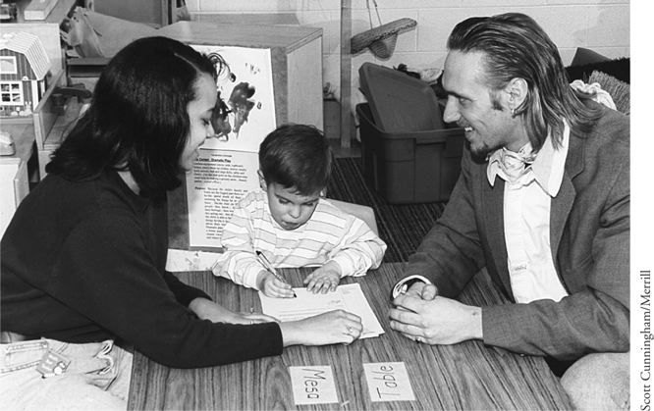
Child care professionals and parents together equal the full picture of child rearing. A good many parents today can’t do it alone. But a child care system can’t do it alone, either, no matter how good it is. Parents and teachers have to be partners.
Another roadblock I’ve encountered in others I’ve worked with is anger and resentment. Tune in on the following scene, which takes place in the living room of a modest home:
The sun is still just a hint in the eastern sky as the doorbell rings. A family child care provider in her bathrobe, who has barely managed to get her hair combed at this early hour, rushes to the door, followed by her fussing baby, who keeps raising his arms to be picked up. She is greeted by a mother who is dressed in a lovely print dress with jacket and jewelry to match. Hiding behind the woman is a sniffling toddler who is wiping her nose on the sleeve of her pajamas. After a rapid exchange of greetings, the mother explains briefly that she will be late tonight because she is taking an important client to dinner. She says a quick good-bye and then turns on her high heels and leaves.
The provider closes the door with a slight slam and leans up against it for a moment before she faces the two needy children who are both fussing at her. Although reminding herself that she made a conscious decision to stay home while her own child is a baby, she is nevertheless resentful of the nice clothes, jewelry, and makeup, as well as the freedom to attend power lunches and client dinners. All of that is totally unrelated to her own day of picking up messes, wiping noses, and changing diapers.
Meanwhile, in the car at the curb, the mother sits for a moment trying to rid herself of the distress she feels at leaving her daughter like this. She wonders whether the sniffles are the beginning of an illness. She wishes she could be there to watch her daughter closely and take care of her. She’s resentful that the provider can be in her bathrobe at this hour and not have to worry about makeup or clothes. She starts up her car, thinking about how nice it would be to have all day to play with children instead of dealing with clients and coworkers in a dog-eat-dog world.
Neither woman in this scenario really wants to trade places with the other, but they both harbor resentments. Consider how these resentments might influence communication between the two. Imagine how the provider will feel tonight if the mother arrives later than she promised. Imagine how the mother will feel if the provider calls in the afternoon and says the child has a fever and must go home regardless of the important dinner scheduled. Will either one feel very understanding? Probably not, with all that resentment that was brewing earlier in the day.
A major issue between parents and child care workers is competition—of all kinds but especially competition for the child’s affection. Because children are likely to be attached to both their parents and their providers, the competition is often intensified. Although in most cases child care workers remain only secondary attachments for children, parents can feel quite insecure about what they perceive as the threat of being replaced as number one in their child’s eyes. It is up to both parents and providers to be aware of the feelings generated by this situation and to learn to respect and relate to each other in supportive ways. Acknowledging the feelings is a first step. Working on the relationship is also a positive approach to take. Setting out purposely to strengthen the relationship is accomplished most easily when all parties involved remind themselves that the child’s welfare is at stake.
We have a model for sharing the care of a child: the extended family so prevalent in many cultures. In this model, the child experiences several simultaneous attachments instead of an exclusive one with the parent alone. There may be a single primary attachment, but the child who grows up in an extended family is likely to be parented by more than one person.
Choosing Child Care: Roberto
Roberto is a single parent and a physical therapist who works with Debbie, the mother in our earlier case study. Roberto has custody of his 4-year-old daughter, Mercedes. Now he is looking for child care, as Debbie had done previously.
When Mercedes was born, Roberto’s mother, Barbara, offered to care for her on a daily basis. The arrangement worked out very well until just recently. Barbara inherited some money, and she’s gotten the travel itch. This itch came at a convenient time, because Roberto was just thinking that Mercedes needed to expand her horizons a bit. Not that she didn’t get what she needed in her grandmother’s home, but Roberto wants her in a program with teachers and other children.
Roberto started his child care search about six months after Debbie did. He felt a good deal of pressure from Debbie to check out Mrs. Watson’s, where Evan was so comfortably settled, so he did. He liked what he saw, but it wasn’t what he wanted for Mercedes. Mrs. Watson was warm and kind, and obviously knew how to provide developmentally appropriate activities for the children in her care. She was also motherly to Roberto, but he bristled at that. “I don’t need another mother,” he told himself.
It was easy to decide against Mrs. Watson’s family child care home. What Roberto wanted for Mercedes was a center.
He visited a number of places, including the ones that Debbie had gone to. Roberto wasn’t as appalled as Debbie was at the variety of programs he found.
Roberto knew what he wanted. It’s just a matter of finding it, he told himself. He wanted a place where Mercedes could experience children and teachers of other cultures—one where teachers were trained to treat 4-year-olds as 4-year-olds and provide a rich variety of creative activities. It was hard for Barbara to open her house to easel painting, clay and play dough, carpentry, and other messy kinds of projects.
Barbara and Roberto have discussed this subject before. They are in agreement. “Those are the kinds of experiences a child care center should provide—ones it’s hard to set up for at home,” Roberto told Barbara.
Barbara agreed. “It will be nice for Mercedes to be with other children, too, instead of all by herself with just me.”
Roberto found several programs that he liked. The one he liked best was in a church. He worried at first that they might teach religion there but was assured that the program was only renting the Sunday school rooms, and it wasn’t affiliated with the church itself.
What Roberto particularly liked about this program was the racial mix of the staff and the atmosphere. He made a couple of visits and was pleased to see the variety of creative activities, including a sensory table and water play, available for the children. When he brought Mercedes to visit, some children were finger painting. Mercedes dived right in and was soon up to her elbows in oozing reds and yellows. She was having a glorious time smearing paint around. No one got upset that she went beyond the paper a couple of times.
Mercedes loved circle time and was the first to grab some streamers and start dancing to the music. She beamed as the teacher sang her name in a good-morning song. There wasn’t anything that Mercedes didn’t love.
“This is the place for us,” Roberto told the teacher as he walked out the door, Mercedes in tow, protesting.
“Can’t I just stay a few more minutes?” his daughter begged.
“You can come back tomorrow and spend all day!” Roberto answered.
LOOKING BACK AND LOOKING FORWARD
The United States has a long way to go as a society to solving the many problems of raising children, but we are at least becoming aware of the problems. A key term in child rearing today is shared care. We’ll make great strides when parents and early care and education teachers and providers become true partners, and when all the adults concerned with a child come to respect, appreciate, and support each other. We know now that children can grow and develop in a variety of settings, including their own homes, family child care homes, and in other kinds of early care and education environments. The key word in any setting is quality.
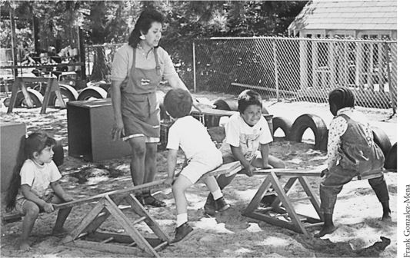
Children can grow and develop in a variety of settings, including their own homes, family child care homes, and other early care and education program settings.
We know, too, that early care and education programs, including Head Start, preschool, and child care, and school can break the cycle of poverty and disadvantage. However, not all programs that serve young children are equally effective. Programs that manage to break the cycle have particular characteristics: They are small, flexible, and interdisciplinary. They often provide more than just early childhood education and child care; they also deliver comprehensive services to meet the child’s needs in the family, and the family’s needs in the community.
It is taking a long time for this society to make children a national priority. The federal child care bill passed at the beginning of the 1990s, the continued funding of Head Start, and the federal and state dollars increasing child care capacities during the welfare reform period were all steps in the right direction.
This chapter took a look at the whole range of early care and education programs and put a focus on child care as a child-rearing setting. The next chapter looks at other resources the community has to offer in addition to early care and education programs.
(Child, Family, and Community: Family-Centered Early Care and Education, 5th Edition. Pearson Learning Solutions pp. 270 - 294).
<vbk:0558582508#outline(15)>

