- Strategic Leadership and Innovation at Apple Inc.
Prepare a case analysis for Case 23-1, Strategic Leadership and Innovation at Apple Inc. The cases analysis (3-5 pages) includes:
Voted as the most innovative company for three consecutive years during 2006 – 2008 and as America’s number 1 most Admired Company (McGregor, 2008), Apple seemed to have it all: innovative products that have redefined their markets (such as iMac and iPod), a consumer base as loyal as a fan club, and a business model characterized by vertical integration and synergies that no competitor could easily imitate. The Apple brand had transcended the barriers of the computer industry to traverse the consumer electronics, record, movie, and the video and music production industries (see Figure 1 for an outline of Apple’s product and service portfolio). In 2008 the Apple brand was listed as the 24th most valuable global brand (up from 33rd place the previous year), valued at $13.7 billion (Interbrand, 2008).
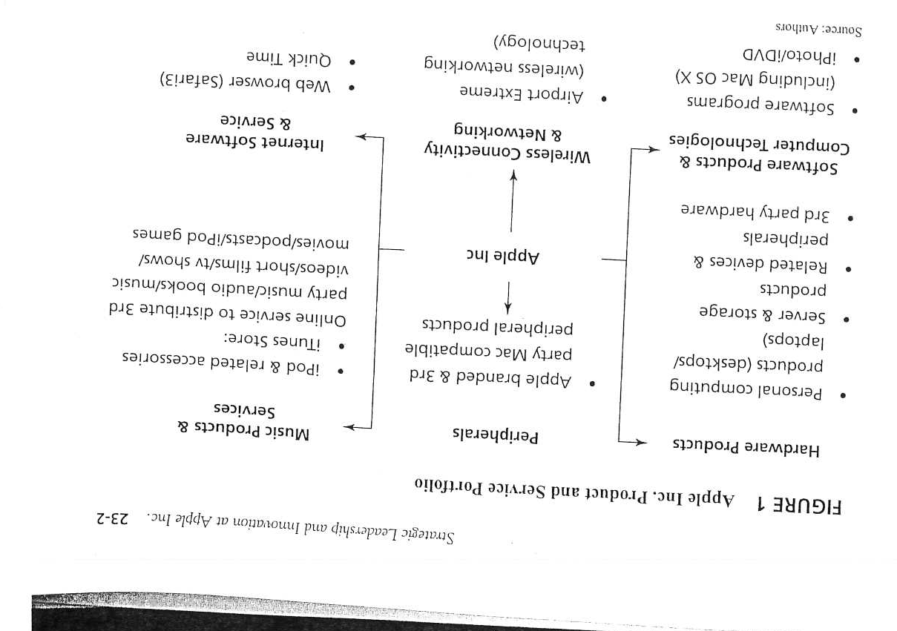

  - A summary of salient points of the case.
  - Answers to key questions:
    - Provide an overview of the computing segment of the computer technology industry and its structure.
    - What are the opportunities and threats facing industry players?
    - What are the keys to success in the industry?
    - Prepare a comparative competitive position evaluation of Apple Inc., and its competitors.
    - What options are open to Apple Inc.?

