Write a program that tests the user’s ability to memorize a sequence of colors. As shown in the sample session, the program starts off by displaying a dialog box with a list of colors that are to be memorized – red, white, yellow, green, and blue. The user then enters the colors one at a time in a text box. If the user makes a mistake, the program prints a “Sorry” message. If the user correctly enters all the colors, the program prints a “Congratulations” message. Note that when the sorry or congratulations message is printed, the window’s original components get cleared away.

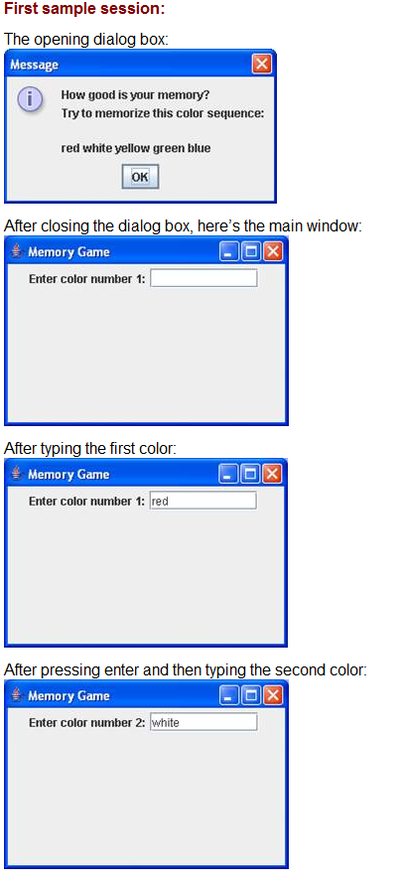
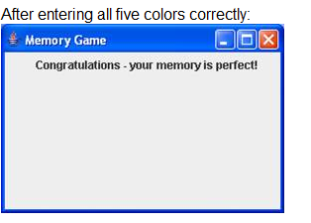
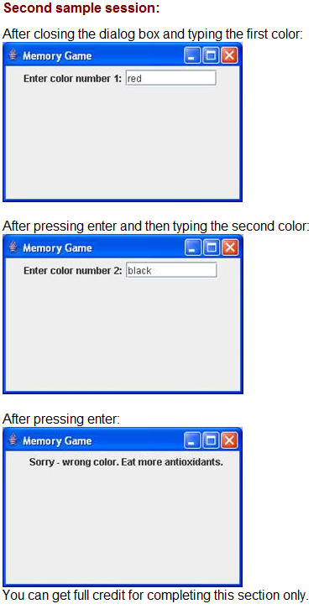

Also provide a hint button that causes the current color’s first letter to appear in the text box. For example, since the first color is red, the first hint should be r. The hint button must cause focus to be put on the text box (i.e., the cursor should appear within the text box without the user having to click there with the mouse). To cause focus to be put on a component, use the requestFocusInWindow method.
