Vintage Cellars
Vintage Cellars manufactures a 1,000-bottle wine storage system that maintains optimum temperature (55-57 °F) and humidity (50-80%) for aging wines. The system has a backup battery for power failures and can store red and white wines at different temperatures. The following table depicts how average cost varies with the number of units manufactured and sold (per month):
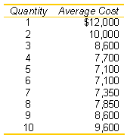

Required:
- Prepare a table that computes the total cost and marginal cost for each quantity between 1 and 10 units.
- What is the relation between average cost and marginal cost?
- What is the opportunity cost of producing one more unit if the company is currently producing and selling four units?
- Vintage Cellars sells the units for $9,000 each. This price does not vary with the number of units sold. How many units should Vintage manufacture and sell each month?
Used by permission of McGraw-Hill.

Sunnybrook Farms
Sunnybrook Farms is a local grocery store that is currently open only Monday through Saturday. Sunnybrook is considering opening on Sundays. The annual incremental costs of Sunday openings are estimated at $24,960. Sunnybrook Farms' gross margin on sales is 20%. Sunnybrook estimates that 60% of its potential Sunday sales to customers are now made on other days. What 1-day volume of Sunday sales would be necessary for Sunnybrook Farms to attain the same weekly operating income as in the current 6-day week?
Used by permission of McGraw-Hill.

Taylor Chemicals
Taylor Chemicals produces a particular chemical at a fixed cost of $1,000 per day. The following table displays how marginal cost varies with output (in cases):
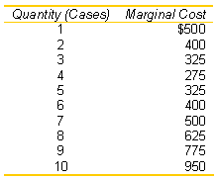
Required:
- Given the preceding data, construct a table that reports total cost and average cost at various output levels from 1 to 10 cases.
- At what quantity is average cost minimized?
- Does marginal cost always intersect average cost at minimum average cost? Why?
Used by permission of McGraw-Hill.

Gas Prices
After the Iraqi invasion of Kuwait in August 1990, the world price of crude oil doubled to more than $30 per barrel in anticipation of reduced supply. Immediately, the oil companies raised the retail price on refined oil products even though these products were produced from oil purchased at the earlier, lower prices: The media charged the oil companies with profiteering and price gouging, and politicians promised immediate investigations.
Required:
Critically evaluate the charge that the oil companies profited from the Iraqi invasion. What advice would you offer the oil companies?
Used by permission of McGraw-Hill.

Penury Company
You are a new consultant with the Boston Group and have been sent to advise the executives of Penury Company. The company recently acquired product line L from an out-of-state concern and now plans to produce it, along with its old standby K, under one roof in a newly renovated facility. Management is quite proud of the acquisition, contending that the larger size and related cost savings will make the company far more profitable. The planned results of a month's operations, based on management's best estimates of the maximum product demanded at today's selling prices are
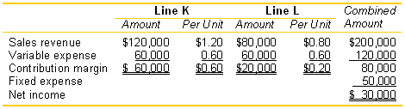
Required:
- Based on historical operations, K alone incurred fixed expenses of $40,000, and L alone incurred fixed expenses of $20,000. Find the break-even point in sales dollars and units for each product separately.
- Give reasons why the fixed costs for the two products combined are expected to be less than the sum of the fixed costs of each product line operating as a separate business.
- Assuming that for each unit of K sold, one unit of L is sold, find the break-even point in sales dollars and units for each product.
Source: Kenneth Gartrell. Used by permission of McGraw-Hill.

Affording a Hybrid
With gasoline prices at $3.00 per gallon, consumers are flocking to purchase hybrid vehicles (combination of gasoline and electric motors) that get 50 miles per gallon of gasoline. The monthly payment on a 3-year lease of a hybrid is $499 compared to $399 per month on a conventional, equivalent traditional gasoline car that gets 25 miles per gallon. Both vehicles require a one-time $1,500 payment for taxes, license, and dealer charges. Both vehicles have identical lease terms for the residual value, maximum number of miles allowed without penalty, and so forth.
Required:
- Calculate how many miles the consumer must drive per year to make the hybrid the economical choice over the conventional gasoline-only vehicle.
- How does your answer to part (a) change if the price of the gasoline is $4.00 per gallon?
Used by permission of McGraw-Hill.

