11
The motor of a ski boat generates an average power of 6.90 10⁴ W when the boat is moving at a constant speed of 15 m/s. When the boat is pulling a skier at the same speed, the engine must generate an average power of 8.70 10⁴ W. What is the tension in the tow rope that is pulling the skier?
N

12
The drawing shows the force-versus-displacement graph for two different bows. These graphs give the force that an archer must apply to draw the bowstring.
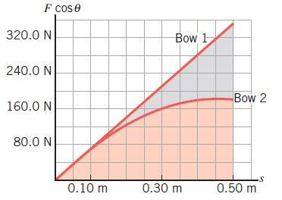
(a) For which bow is more work required to draw the bow fully from s = 0 to s = 0.50 m?
bow 1bow 2
Give your reasoning.
(b) Estimate the additional work required for the bow identified in part (a) compared to the other bow.

13.
A net external force is applied to a 7.58-kg object that is initially at rest. The net force component along the displacement of the object varies with the magnitude of the displacement as shown in the drawing. What is the speed of the object at s = 20.0 m?
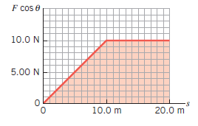
v_{f} =

14.

Two pole-vaulters just clear the bar at the same height. The first lands at a speed of 8.60 m/s, and the second lands at a speed of 8.90 m/s. The first vaulter clears the bar at a speed of 1.00 m/s. Ignore air resistance and friction and determine the speed at which the second vaulter clears the bar.
m/s

