1.) Draw the two compounds (one containing N and the other Br) that could react by SN2 reaction to give the following compound:
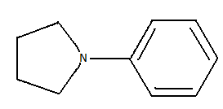

2.) Draw the simpler alkyne and alkyl bromide that could be combined to give the alkyne shown:
